Medicare Certification Survey Day Simulation — Architecture & Build Roadmap

Complete Architecture Document v1.0

Table of Contents
- Product Purpose
- User Roles
- Survey-Day Timeline
- Simulation Phases
- Data Model
- Workflow Model
- Scoring Model
- Evidence Model
- Brad / iAdministrator Integration
- UI Route / Page Architecture
- Component Architecture [blocked]
- Event / State Management
- Audit Trail
- Reporting Outputs
- Integration Points
- Build Roadmap
- Deliverables Summary

1. Product Purpose

1.1 Mission Statement
The Medicare Certification Survey Day Simulation is a training, assessment, and readiness module that walks home health agency leadership and staff through a realistic Medicare initial certification survey experience — end to end — inside a controlled, simulated environment.

1.2 What It Is
Function | Description
Training Simulator | Teaches staff what surveyors ask, how to respond, and where evidence lives
Readiness Assessment | Scores the agency's preparedness across all survey domains before a real survey
Workflow Execution Guide | Orchestrates who does what, when, and in what order during survey day
Documentation Stress Test | Validates that all required policies, forms, records, and evidence are present, current, and accessible
Audit Packet Validator | Assembles and verifies evidence packets against surveyor request types
Leadership Response Practice | Trains administrators, DONs, and governing body on real-time decision-making under survey pressure

1.3 What It Is NOT
⚠️ DISCLAIMER — Prominently displayed on every simulation screen: "This is a readiness simulation for internal training purposes only. It does not guarantee Medicare certification. It does not replicate the exact methodology of any specific state survey agency or CMS contractor. Use it to identify gaps, practice response workflows, and build confidence — not as a substitute for actual regulatory consultation."

1.4 Design Principles
- Realism over perfection — Mirror real survey pressure, pacing, and ambiguity
- Evidence-first — Every request must resolve to a tangible artifact or flag a gap
- Role-aware — Each user sees only what their role requires during the simulation
- Coaching-embedded — Brad provides contextual guidance at every phase, not just at the end
- Measurable — Every interaction produces a scorable, auditable data point
- Non-punitive — Simulation findings are learning opportunities, not disciplinary events
- Repeatable — Agencies should run the simulation multiple times as they remediate gaps

2. User Roles

2.1 Role Matrix
Role | Simulation Function | Survey-Day Responsibility | Brad Access Level
Administrator | Simulation owner; leads entrance/exit conference; escalation point | Primary agency contact for surveyor; provides organizational documents | Full — all phases
Director of Nursing / Clinical Manager | Clinical evidence lead; patient record review lead; staff competency attestor | Responds to clinical questions; provides patient records; validates care processes | Full — clinical phases
QAPI Coordinator | QAPI evidence lead; quality indicator presenter | Presents QAPI plan, PIPs, committee minutes, trend data | Full — QAPI + quality phases
Compliance Officer | Policy/procedure evidence lead; regulatory alignment validator | Ensures policy currency; manages document request queue; tracks evidence completeness | Full — all phases
HR Director | Personnel file evidence lead; credential verification attestor | Provides personnel files; validates licensure, background checks, OIG/SAM screening | Full — personnel phases
Intake Coordinator | Referral/intake evidence lead; eligibility documentation provider | Demonstrates referral-to-admission workflow; provides intake documentation | Guided — intake/eligibility
Medical Records | Clinical documentation custodian; record assembly lead | Assembles patient charts; verifies completeness; provides discharge/transfer records | Guided — clinical record phases
Billing / Revenue Cycle | Billing-to-clinical alignment validator; claims documentation provider | Demonstrates billing holds for missing documentation; provides claims evidence | Guided — billing/OASIS phases
Field Clinician | Interview subject; home visit observation participant; documentation author | Answers survey questions; demonstrates clinical practice; provides visit notes | Coached — interview + visit
Governing Body Member | Governance attestor; oversight evidence provider | Confirms governance structure; provides meeting minutes; approves QAPI plan | Briefed — governance phases
Surveyor Persona | AI-driven or trainer-controlled antagonist; generates requests and probes | Asks questions, requests documents, identifies gaps, conducts interviews | N/A — is the challenge
Observer / Trainer | Watches simulation without participating; provides coaching notes post-simulation | Monitors all phases; provides feedback; adjusts difficulty; reviews scores | Full read-only + coaching

2.2 Role Capabilities
Administrator: [start_sim, manage_sim, respond, escalate, close_sim, view_all, export]
DON/ClinicalMgr: [respond, review_clinical, attest, delegate, view_clinical, export]
QAPICoordinator: [respond, present_qapi, upload_evidence, view_qapi, export]
ComplianceOfficer: [respond, manage_queue, verify_policy, flag_gap, view_all, export]
HRDirector: [respond, provide_personnel, verify_credentials, view_hr, export]
IntakeCoordinator: [respond, provide_intake, view_intake]
MedicalRecords: [respond, assemble_records, provide_records, view_clinical]
Billing: [respond, verify_billing_alignment, provide_claims, view_billing]
FieldClinician: [respond_interview, perform_visit_sim, view_own]
GoverningBody: [attest, provide_governance, view_governance]
SurveyorPersona: [generate_request, probe, score, flag, conduct_interview, observe_visit]
Observer: [view_all, add_coaching_note, adjust_difficulty, export]

2.3 Role Assignment Rules
- A simulation requires at minimum: Administrator, DON, Compliance Officer, and Surveyor Persona (AI or human)
- One user may hold multiple roles (e.g., Administrator + Compliance Officer in a small agency)
- The Surveyor Persona can be:
  - AI-driven (Brad generates requests from the Surveyor Request Engine)
  - Trainer-controlled (a human selects requests from the engine)
  - Hybrid (AI generates, trainer approves/modifies before delivery)
- Roles are assigned during the Start Simulation Wizard and can be adjusted mid-simulation by the Administrator

3. Survey-Day Timeline

3.1 Realistic Timeline Model
The simulation models a realistic 1–2 day Medicare initial certification survey. Time can be compressed for training.
┌─────────────────────────────────────────────────────────────────────┐
│ SURVEY DAY TIMELINE │
├──────────┬──────────────────────────────────────────────────────────┤
│ TIME │ PHASE │
├──────────┼──────────────────────────────────────────────────────────┤
│ Pre-Day │ Phase 1: Pre-Survey Readiness Check │
│ │ (Can be run days/weeks before simulation) │
├──────────┼──────────────────────────────────────────────────────────┤
│ 08:00 │ Phase 2: Surveyor Arrival / Entrance Conference │
│ │ (30–45 min) │
├──────────┼──────────────────────────────────────────────────────────┤
│ 08:45 │ Phase 3: Document Request Sprint │
│ │ (60–90 min, ongoing throughout day) │
├──────────┼──────────────────────────────────────────────────────────┤
│ 09:00 │ Phase 4: Policy & Procedure Review │
│ │ (concurrent with Phase 3) │
├──────────┼──────────────────────────────────────────────────────────┤
│ 09:30 │ Phase 5: Personnel File Review │
│ │ (concurrent) │
├──────────┼──────────────────────────────────────────────────────────┤
│ 10:30 │ Phase 6: Clinical Record Review │
│ │ (major block, 2–3 hours) │
├──────────┼──────────────────────────────────────────────────────────┤
│ 11:00 │ Phase 7: OASIS / POC Traceability Drill │
│ │ (within clinical record review) │
├──────────┼──────────────────────────────────────────────────────────┤
│ 13:00 │ Phase 8: Staff Interview Simulation │
│ │ (1–2 hours, multiple staff) │
├──────────┼──────────────────────────────────────────────────────────┤
│ 14:00 │ Phase 9: Home Visit Observation Simulation │
│ │ (1–2 hours, field component) │
├──────────┼──────────────────────────────────────────────────────────┤
│ 15:00 │ Phase 10: QAPI Review │
│ │ (45–60 min) │
├──────────┼──────────────────────────────────────────────────────────┤
│ 15:45 │ Phase 11: Emergency Preparedness Review │
│ │ (30–45 min) │
├──────────┼──────────────────────────────────────────────────────────┤
│ 16:30 │ Phase 12: Exit Conference │
│ │ (30–60 min) │
├──────────┼──────────────────────────────────────────────────────────┤
│ Post-Day │ Phase 13: Post-Survey Corrective Action Plan │
│ │ (generated immediately, tracked over days/wks) │
└──────────┴──────────────────────────────────────────────────────────┘

3.2 Time Modes
Mode | Description | Use Case
Real-Time | Simulation runs on actual clock; timers are real | Full dress rehearsal
Compressed | 1 day = 2–3 hours; timers proportionally shortened | Quick training run
Phase-by-Phase | Run one phase at a time; pause between phases | Targeted practice
Untimed | No timers; focus on completeness over speed | Learning mode

4. Simulation Phases — Detailed Architecture

Phase 1: Pre-Survey Readiness Check
Purpose: Baseline assessment of whether the agency has the foundational documentation in place before a surveyor arrives.
Trigger: Administrator starts readiness check from the Simulation Dashboard.
Checklist Engine:
Category | Required Items | Source System | Verification Method
Policies & Procedures | All CoP-required policies present, current, approved, acknowledged | Policy Library | Version check, approval status, acknowledgment %
Forms & Appendices | All referenced forms linked and current | Forms Library | Link validation, version check
Governing Body Records | Charter, member list, meeting minutes (last 12 mo), QAPI approval | Governance collection | Record existence, date currency
Administrator/DON Appointment | Appointment letters, qualifications, job descriptions | Personnel collection | Record existence, date validity
QAPI Program | QAPI plan, committee roster, meeting minutes, active PIPs, indicators | QAPI collection | Completeness check against CMS requirements
Emergency Preparedness | EP plan, HVA, communication plan, drill records, AAR | EP collection | Completeness, date currency (annual requirements)
Personnel Files | Sample N files with all required components | Personnel collection | Component checklist per file
Patient Clinical Records | Sample N records with all required components | Clinical records collection | Component checklist per record
Infection Control | IC plan, surveillance log, training records, supplies checklist | IC collection | Record existence, currency
HIPAA/Security | Privacy policies, BAAs, training records, breach log, risk analysis | Compliance collection | Record existence, currency
Complaint Log | Complaint intake form, investigation records, resolution tracking | Complaints collection | Record existence, process completeness
Incident/Adverse Event Log | Incident reports, investigation records, trend analysis | Incidents collection | Record existence, trend evidence
Output: Pre-Survey Readiness Score Card with pass/warn/fail per category.
Brad Actions:
- brief_readiness_check — Explains what CMS surveyors expect before arrival
- locate_missing_items — Identifies specific gaps
- recommend_remediation — Suggests priority fixes

Phase 2: Surveyor Arrival / Entrance Conference
Purpose: Simulate the first 30–45 minutes of a real survey: surveyor identification, agency introduction, scope declaration, and initial document requests.
Events:
Step | Actor | Action | System Response
2.1 | Surveyor | Presents credentials | App records surveyor name, ID, agency, scope
2.2 | System | Captures attendance | App records all participants, roles, timestamps
2.3 | Administrator | Delivers agency introduction | App provides a template/checklist for introduction content
2.4 | Surveyor | Declares survey scope | App records scope (initial cert, recert, complaint, etc.)
2.5 | Surveyor | Issues initial document request list | Surveyor Request Engine generates list; timer starts
2.6 | Administrator | Assigns response roles | App routes each request to the appropriate evidence owner
2.7 | System | Opens Document Request Queue | Phase 3 begins concurrently
Data Captured:
- EntranceConferenceRecord: surveyor info, attendees, scope, start time, initial requests, role assignments
Brad Actions:
- brief_entrance_conference — Tells the Administrator what to expect
- generate_introduction_checklist — Provides a structured intro script
- explain_document_request — Interprets each request for the team

Phase 3: Document Request Sprint
Purpose: Simulate the high-pressure, time-sensitive document retrieval that occurs throughout a real survey.
Surveyor Request Engine Integration:
Each request generated by the engine includes:
SurveyRequest {
id: string
requestText: string // "Show me your governing body meeting minutes..."
category: SurveyCategory // governance, clinical, personnel, etc.
phase: SimulationPhase // which phase generated this request
requiredPolicyIds: string[] // links to policy library
requiredFormIds: string[] // links to forms library
requiredEvidenceTypes: EvidenceType[]
ownerRole: UserRole // who should respond
assignedUserId: string | null // specific user assigned
responseTimerMinutes: number // expected response time
scoringCriteria: ScoringCriteria
failureCondition: string // what constitutes a failure
remediationWorkflowId: string // workflow to trigger if failed
status: 'pending' | 'assigned' | 'in_progress' | 'submitted' | 'verified' | 'failed' | 'escalated'
priority: 'standard' | 'urgent' | 'critical'
createdAt: timestamp
dueAt: timestamp
submittedAt: timestamp | null
verifiedAt: timestamp | null
}
Queue Mechanics:
- Requests enter the Document Request Queue
- Compliance Officer (or designated role) triages and assigns
- Evidence owner locates/assembles evidence
- Evidence packet submitted to queue
- Compliance Officer verifies completeness
- Packet marked as submitted to surveyor
- If timer expires → auto-escalate → flag as overdue
Escalation Chain:
Timer at 50% → Yellow warning to owner
Timer at 75% → Orange warning to owner + Compliance Officer
Timer at 100% → Red alert to Administrator + DON
Timer at 125% → Auto-flag as "failed to produce in timely manner"
Brad Actions:
- open_evidence_request — Shows the owner exactly what's needed
- locate_policy — Finds the relevant policy in the library
- locate_form — Finds the relevant form/appendix
- assemble_survey_packet — Helps build the evidence bundle
- explain_urgency — Tells the user why this matters and what the risk is

Phase 4: Policy and Procedure Review
Purpose: Surveyor examines selected policies for currency, completeness, approval, and staff acknowledgment.
Review Checklist Per Policy:
Check | Method | Source
Policy exists | Policy Library lookup | Policy collection
Current version | Version date ≤ 12 months or per policy schedule | Policy metadata
Approved | Approval workflow completed | Workflow engine
Acknowledged by staff | Acknowledgment % meets threshold | Acknowledgment records
Linked forms/appendices present | Form/appendix links resolve | Forms library
Content aligns with CoP requirement | Brad content analysis (optional) | Policy content + CoP reference
Surveyor Selection Methods:
- Random selection from all policies
- Targeted selection by CoP area (e.g., all infection control policies)
- Risk-weighted selection (policies linked to previous findings)
Brad Actions:
- verify_policy_status — Checks all status fields
- locate_linked_forms — Finds all attached forms/appendices
- explain_policy_requirement — Explains why CMS requires this policy
- flag_outdated_policy — Alerts if policy is past review date

Phase 5: Personnel File Review
Purpose: Surveyor selects a sample of staff files and verifies required components.
Sample Selection:
- Surveyor (or engine) selects N staff files (typically 5–10)
- Selection may be random or targeted by role (e.g., all RNs, a mix of disciplines)
Component Checklist Per File:
Component | Verification | Data Source
Active professional license | License number, state, expiration, primary source verification | Personnel record
Background check | Type, date, clearance status | Personnel record
OIG exclusion screening | Date of last check, result, monthly cadence | OIG/SAM integration
SAM exclusion screening | Date of last check, result | OIG/SAM integration
Health clearance | TB test, physical, hepatitis B declination/vaccination | Health records
Competency validation | Skills checklist, clinical competency assessment, date | Competency collection
Orientation completion | Orientation checklist, date completed, sign-off | Onboarding journey
Annual training completion | Required trainings, completion dates, certificates | Training records
Job description acknowledgment | Signed/acknowledged job description, date | Personnel record
Policy acknowledgments | Required policy acknowledgments completed | Acknowledgment records
Scoring: Each component is pass/fail per file. Overall file score = % components present and current.
Brad Actions:
- check_personnel_file — Runs the full component checklist
- flag_missing_components — Identifies specific gaps
- explain_oig_requirement — Explains OIG/SAM screening requirements
- recommend_remediation — Suggests fix actions with due dates

Phase 6: Clinical Record Review
Purpose: Surveyor selects a sample of patient records and verifies clinical documentation completeness and consistency.
Sample Selection:
- Engine selects N patient records (typically 8–12 for initial certification)
- Selection stratified by: active/discharged, discipline mix, payer, diagnosis complexity
Component Checklist Per Record:
Component | Verification | Data Source
Referral / Intake | Referral source, date, intake assessment, eligibility screening | Intake records
Eligibility determination | Homebound status, skilled need, physician certification | Eligibility records
Comprehensive assessment | Completed within required timeframe, all domains addressed | Assessment records
OASIS assessment | Completed, transmitted, status (accepted/rejected), correction status | OASIS records
Plan of Care (POC) / 485 | Current, signed by physician, matches assessment findings | POC records
Physician orders | Signed, dated, match POC, verbal order protocols followed | Orders records
Visit notes | Present for all authorized visits, complete, consistent with POC | Visit records
Medication reconciliation | Current medication profile, reconciliation at SOC and recert | Med records
Care coordination | Communication between disciplines, MD communication, referral to other services | Coordination records
Patient rights | Rights notification signed, advance directive status documented | Patient records
Discharge / Transfer | If applicable: summary, notification, follow-up plan | Discharge records
Documentation consistency | Assessment → POC → Orders → Notes → Billing alignment | Cross-record analysis
Brad Actions:
- review_clinical_record — Runs full component checklist
- trace_documentation_chain — Follows the referral-to-discharge thread
- flag_inconsistency — Identifies mismatches between documents
- explain_requirement — Explains the CoP basis for each requirement

Phase 7: OASIS / POC Traceability Drill
Purpose: Deep verification that OASIS responses are supported by clinical evidence, POC reflects OASIS findings, orders align with POC, and visit notes execute the POC.
Traceability Chain:
OASIS Item (e.g., M1800 Grooming)
↓ supported by
Clinical Evidence (assessment narrative, visit note observation)
↓ reflected in
POC Goal/Intervention (functional goal for grooming)
↓ authorized by
Physician Order (OT evaluation and treatment for ADL training)
↓ executed in
Visit Note (OT visit note documenting grooming intervention)
↓ billed as
Claim Line (OT visit on date of service)
Verification Points:
Check | Question | Fail Condition
OASIS evidence source | Is there clinical documentation supporting this OASIS response? | No supporting evidence found
OASIS → POC consistency | Does the POC address the problems identified in OASIS? | OASIS shows deficit; POC has no related goal
POC → Orders consistency | Are there physician orders for all POC interventions? | POC has intervention; no matching order
POC → Visit Note consistency | Do visit notes document execution of POC interventions? | POC intervention exists; no visit notes address it
Billing hold check | If required documentation is missing, is billing held? | Missing documentation but claim submitted
Admin/DON approval | Has the POC been reviewed/approved by administrator or DON? | No approval signature/status
Physician signature | Is the POC signed by the physician within required timeframe? | Unsigned or late signature
Brad Actions:
- trace_oasis_item — Follows one OASIS item through the full chain
- identify_traceability_gaps — Finds breaks in the chain
- explain_oasis_requirement — Explains CMS OASIS guidance
- recommend_billing_hold — Suggests hold if documentation insufficient

Phase 8: Staff Interview Simulation
Purpose: Surveyor interviews staff members about their knowledge of agency policies, procedures, patient care processes, and emergency procedures.
Interview Architecture:
InterviewSession {
id: string
simulationId: string
intervieweeRole: UserRole
intervieweeUserId: string
surveyorPersonaId: string
questions: InterviewQuestion[]
responses: InterviewResponse[]
overallScore: number
coachingFeedback: string
startedAt: timestamp
completedAt: timestamp
}

InterviewQuestion {
id: string
questionText: string
targetRole: UserRole[] // which roles should answer this
category: InterviewCategory // infection_control, patient_rights, emergency, etc.
relatedPolicyIds: string[] // the policies that contain the answer
expectedAnswerElements: string[] // key points the answer should include
scoringRubric: ScoringRubric
difficulty: 'basic' | 'intermediate' | 'advanced'
}

InterviewResponse {
questionId: string
responseText: string
responseTimestamp: timestamp
bradScore: number // 0-100
bradAnalysis: string // what was good, what was missing
matchedElements: string[] // which expected elements were covered
missedElements: string[] // which expected elements were missed
relatedPolicyContent: string // the actual policy text for coaching
coachingNote: string // Brad's coaching feedback
}
Question Bank Categories:
- Patient Rights & Responsibilities
- Infection Control & Prevention
- Emergency Procedures
- Abuse/Neglect Reporting
- HIPAA/Privacy
- Care Planning Process
- Medication Management
- Incident Reporting
- Complaint Process
- Supervision & Delegation
- Advance Directives
- Home Safety
- Cultural Competency
- Discharge Planning
Brad Grading Logic:
- Parse response text for expected answer elements
- Match against related policy content
- Flag vague responses (e.g., "follow protocol" without specifying which protocol)
- Surface the actual protocol text as coaching
- Score based on: accuracy, completeness, specificity, policy alignment
- Generate coaching feedback with specific improvement suggestions
Brad Actions:
- start_staff_interview — Initiates interview session for a role
- grade_response — Scores and analyzes the response
- surface_policy — Shows the actual policy content the answer should reference
- generate_coaching — Creates personalized coaching feedback
- flag_knowledge_gap — Identifies systemic training gaps

Phase 9: Home Visit Observation Simulation
Purpose: Surveyor observes a mock home visit to verify clinician adherence to clinical and regulatory standards.
Observation Checklist:
Behavior | Expected Standard | Scoring
Identification | Clinician introduces self, shows ID, states agency | Pass/Fail
Patient rights | Rights reviewed/reinforced at visit | Pass/Fail
Infection control | Hand hygiene, PPE, bag technique, equipment cleaning | Multi-point scale
Medication review | Current medications reviewed, reconciled, patient educated | Multi-point scale
Safety assessment | Home safety evaluated, hazards identified, interventions documented | Multi-point scale
Documentation standards | Visit note started timely, complete, legible, signed | Multi-point scale
Care plan alignment | Visit activities align with POC goals/interventions | Multi-point scale
Clinical concern escalation | Appropriate escalation of new findings, MD notification | Conditional (if applicable)
Simulation Modes:
- Scenario-based: App presents a patient scenario; clinician walks through what they would do; Brad evaluates
- Checklist-based: Observer/trainer uses the checklist to score a role-play or verbal walkthrough
- Interactive: Brad plays the patient; clinician responds in real-time
Brad Actions:
- present_visit_scenario — Generates a realistic patient visit scenario
- evaluate_visit_performance — Scores against the observation checklist
- coach_clinical_practice — Provides specific improvement guidance
- flag_safety_concern — Identifies critical practice gaps

Phase 10: QAPI Review
Purpose: Surveyor evaluates the agency's Quality Assessment and Performance Improvement program.
Review Checklist:
Component | Required Evidence | Verification
QAPI Plan | Written plan addressing all 5 CMS elements | Document exists, dated, current
Committee Structure | Roster, charter, meeting schedule | Documents exist
Committee Minutes | Minutes from last 12 months of meetings | Records exist, substantive content
Quality Indicators | Defined indicators, baseline data, trend tracking | Data exists, trends visible
Active PIPs | At least 1 active PIP, PDSA methodology, measurable aim | PIP records with all components
Adverse Event Analysis | Root cause analysis process, completed analyses | Process documented, examples exist
Infection Trends | Infection surveillance data, trend analysis | Data exists, analysis documented
Patient Satisfaction | Survey data, trend analysis, action items | Data exists, analysis documented
Governing Body Oversight | Evidence of GB review/approval of QAPI plan and results | Meeting minutes with QAPI items
Corrective Action Tracking | CAP log with follow-up and closure evidence | Active tracking system
Brad Actions:
- review_qapi_program — Runs full QAPI checklist
- assess_pip_quality — Evaluates PIP methodology and progress
- identify_qapi_gaps — Finds missing components
- explain_qapi_requirement — Explains the 5 CMS QAPI elements

Phase 11: Emergency Preparedness Review
Purpose: Surveyor evaluates the agency's emergency preparedness program against CMS EP requirements.
Review Checklist:
Component | Required Evidence | Verification
Emergency Plan | All-hazards plan addressing CMS required elements | Document exists, current, comprehensive
Hazard Vulnerability Assessment | HVA completed, risks prioritized, mitigation strategies | Document exists, dated within 12 months
Communication Plan | Contact lists, backup communications, patient notification plan | Document exists, tested
Staff Training | EP orientation, annual training, documentation | Training records exist for all staff
Exercises/Drills | 2 per year (1 full-scale/functional, 1 may be tabletop) | Drill records with dates, participants
After-Action Reports | AAR for each drill, improvement items identified | AARs exist, improvement items tracked
Patient Risk Stratification | Patients categorized by risk level for emergencies | System/process documented
Continuity Plan | Business continuity, succession, alternate site | Document exists
Brad Actions:
- review_ep_program — Runs full EP checklist
- check_drill_compliance — Verifies drill frequency and documentation
- explain_ep_requirement — Explains CMS EP rule requirements
- flag_ep_gaps — Identifies critical deficiencies

Phase 12: Exit Conference
Purpose: Surveyor presents preliminary findings; leadership responds; corrective action planning begins.
Conference Flow:
- Finding Presentation: App generates preliminary findings from all phases
- Finding Categorization:
Category | Description | Color | Action Required
Compliant | Meets requirements | 🟢 Green | None — document strength
Concern | Minor gap, easily remediated | 🟡 Yellow | Voluntary CAP recommended
Deficiency Risk | Significant gap, would likely result in citation | 🔴 Red | Mandatory CAP required
Immediate Jeopardy (Sim Only) | Critical patient safety risk | ⚫ Black | Immediate action required — leadership escalation
- Leadership Response: For each finding, leadership records:
  - Acknowledgment or dispute
  - Initial response plan
  - Responsible party
  - Timeline commitment
- Next Steps: App generates a corrective action roadmap
Brad Actions:
- generate_findings_summary — Creates the preliminary findings report
- categorize_findings — Assigns severity levels
- recommend_responses — Suggests leadership response language
- generate_cap_roadmap — Creates the corrective action timeline

Phase 13: Post-Survey Corrective Action Plan
Purpose: Convert findings into actionable remediation tasks with owners, deadlines, and evidence requirements.
CAP Structure:
CorrectiveActionPlan {
id: string
simulationId: string
findingId: string
category: FindingCategory
description: string
rootCause: string
correctiveAction: string
preventiveAction: string
ownerUserId: string
ownerRole: UserRole
dueDate: timestamp
evidenceRequired: EvidenceRequirement[]
status: 'open' | 'in_progress' | 'evidence_submitted' | 'verified' | 'closed'
followUpChecks: FollowUpCheck[]
governingBodyEscalation: boolean
escalationReason: string | null
createdAt: timestamp
updatedAt: timestamp
closedAt: timestamp | null
}

RemediationTask {
id: string
capId: string
taskDescription: string
ownerUserId: string
dueDate: timestamp
evidenceType: EvidenceType
status: 'pending' | 'in_progress' | 'completed' | 'overdue'
completedAt: timestamp | null
evidenceArtifactId: string | null
}
Brad Actions:
- generate_CAP — Creates CAP from findings
- assign_remediation_tasks — Breaks CAP into actionable tasks
- track_cap_progress — Monitors completion status
- certify_remediation_complete — Validates evidence and closes tasks
- escalate_to_governing_body — Flags items requiring GB attention

5. Data Model

5.1 Core Models / TypeScript Interfaces
// ============================================================
// ENUMS
// ============================================================

enum SimulationStatus {
DRAFT = 'draft',
READINESS_CHECK = 'readiness_check',
IN_PROGRESS = 'in_progress',
PAUSED = 'paused',
EXIT_CONFERENCE = 'exit_conference',
CAP_PHASE = 'cap_phase',
COMPLETED = 'completed',
ARCHIVED = 'archived'
}

enum SimulationPhase {
PRE_SURVEY_READINESS = 'pre_survey_readiness',
ENTRANCE_CONFERENCE = 'entrance_conference',
DOCUMENT_REQUEST_SPRINT = 'document_request_sprint',
POLICY_REVIEW = 'policy_review',
PERSONNEL_FILE_REVIEW = 'personnel_file_review',
CLINICAL_RECORD_REVIEW = 'clinical_record_review',
OASIS_POC_TRACEABILITY = 'oasis_poc_traceability',
STAFF_INTERVIEW = 'staff_interview',
HOME_VISIT_OBSERVATION = 'home_visit_observation',
QAPI_REVIEW = 'qapi_review',
EMERGENCY_PREPAREDNESS = 'emergency_preparedness',
EXIT_CONFERENCE = 'exit_conference',
CORRECTIVE_ACTION_PLAN = 'corrective_action_plan'
}

enum UserRole {
ADMINISTRATOR = 'administrator',
DON_CLINICAL_MANAGER = 'don_clinical_manager',
QAPI_COORDINATOR = 'qapi_coordinator',
COMPLIANCE_OFFICER = 'compliance_officer',
HR_DIRECTOR = 'hr_director',
INTAKE_COORDINATOR = 'intake_coordinator',
MEDICAL_RECORDS = 'medical_records',
BILLING_REVENUE_CYCLE = 'billing_revenue_cycle',
FIELD_CLINICIAN = 'field_clinician',
GOVERNING_BODY_MEMBER = 'governing_body_member',
SURVEYOR_PERSONA = 'surveyor_persona',
OBSERVER_TRAINER = 'observer_trainer'
}

enum FindingCategory {
COMPLIANT = 'compliant',
CONCERN = 'concern',
DEFICIENCY_RISK = 'deficiency_risk',
IMMEDIATE_JEOPARDY = 'immediate_jeopardy'
}

enum EvidenceType {
POLICY = 'policy',
FORM = 'form',
APPENDIX = 'appendix',
RECORD = 'record',
CERTIFICATE = 'certificate',
MEETING_MINUTES = 'meeting_minutes',
TRAINING_RECORD = 'training_record',
SCREENING_RESULT = 'screening_result',
ASSESSMENT = 'assessment',
PLAN_OF_CARE = 'plan_of_care',
PHYSICIAN_ORDER = 'physician_order',
VISIT_NOTE = 'visit_note',
OASIS = 'oasis',
DRILL_RECORD = 'drill_record',
SIGNATURE = 'signature',
ATTESTATION = 'attestation',
REPORT = 'report',
LOG = 'log',
OTHER = 'other'
}

enum SurveyCategory {
GOVERNANCE = 'governance',
ADMINISTRATION = 'administration',
CLINICAL = 'clinical',
PERSONNEL = 'personnel',
INFECTION_CONTROL = 'infection_control',
QAPI = 'qapi',
EMERGENCY_PREPAREDNESS = 'emergency_preparedness',
PATIENT_RIGHTS = 'patient_rights',
HIPAA_PRIVACY = 'hipaa_privacy',
BILLING_COMPLIANCE = 'billing_compliance',
COMPLAINTS = 'complaints',
INCIDENT_MANAGEMENT = 'incident_management'
}

enum RequestStatus {
PENDING = 'pending',
ASSIGNED = 'assigned',
IN_PROGRESS = 'in_progress',
SUBMITTED = 'submitted',
VERIFIED = 'verified',
FAILED = 'failed',
ESCALATED = 'escalated'
}

enum RequestPriority {
STANDARD = 'standard',
URGENT = 'urgent',
CRITICAL = 'critical'
}

enum TimeMode {
REAL_TIME = 'real_time',
COMPRESSED = 'compressed',
PHASE_BY_PHASE = 'phase_by_phase',
UNTIMED = 'untimed'
}

enum ScoreVerdict {
PASS = 'pass',
WARN = 'warn',
FAIL = 'fail'
}

enum CAPStatus {
OPEN = 'open',
IN_PROGRESS = 'in_progress',
EVIDENCE_SUBMITTED = 'evidence_submitted',
VERIFIED = 'verified',
CLOSED = 'closed'
}

enum TaskStatus {
PENDING = 'pending',
IN_PROGRESS = 'in_progress',
COMPLETED = 'completed',
OVERDUE = 'overdue'
}

enum InterviewCategory {
PATIENT_RIGHTS = 'patient_rights',
INFECTION_CONTROL = 'infection_control',
EMERGENCY_PROCEDURES = 'emergency_procedures',
ABUSE_NEGLECT = 'abuse_neglect',
HIPAA_PRIVACY = 'hipaa_privacy',
CARE_PLANNING = 'care_planning',
MEDICATION_MANAGEMENT = 'medication_management',
INCIDENT_REPORTING = 'incident_reporting',
COMPLAINT_PROCESS = 'complaint_process',
SUPERVISION_DELEGATION = 'supervision_delegation',
ADVANCE_DIRECTIVES = 'advance_directives',
HOME_SAFETY = 'home_safety',
CULTURAL_COMPETENCY = 'cultural_competency',
DISCHARGE_PLANNING = 'discharge_planning'
}

enum SurveyorPersonaType {
AI_DRIVEN = 'ai_driven',
TRAINER_CONTROLLED = 'trainer_controlled',
HYBRID = 'hybrid'
}

enum DifficultyLevel {
BASIC = 'basic',
INTERMEDIATE = 'intermediate',
ADVANCED = 'advanced'
}

// ============================================================
// CORE SIMULATION
// ============================================================

interface SurveySimulation {
id: string;
title: string;
description: string;
status: SimulationStatus;
currentPhase: SimulationPhase;
timeMode: TimeMode;
difficultyLevel: DifficultyLevel;
surveyorPersonaType: SurveyorPersonaType;

// Configuration
config: SimulationConfig;

// Participants
participants: SimulationParticipant[];

// Phase tracking
phases: PhaseRecord[];

// Results
overallScore: SimulationScorecard | null;
findings: SurveyFinding[];

// Metadata
createdBy: string;
createdAt: string; // ISO timestamp
startedAt: string | null;
completedAt: string | null;
updatedAt: string;

// Disclaimer acknowledged
disclaimerAcknowledged: boolean;
disclaimerAcknowledgedBy: string;
disclaimerAcknowledgedAt: string | null;
}

interface SimulationConfig {
// Sample sizes
personnelFileSampleSize: number; // default: 5
clinicalRecordSampleSize: number; // default: 8
interviewSampleSize: number; // default: 6

// Timer configuration
documentRequestTimerMinutes: number; // default: 30
timerCompressionRatio: number; // 1.0 = real-time, 0.25 = 4x compressed

// Scope
includedPhases: SimulationPhase[]; // which phases to include
focusCategories: SurveyCategory[]; // optional focus areas

// Surveyor behavior
surveyorAggressiveness: 'gentle' | 'moderate' | 'aggressive';
followUpDepth: 'shallow' | 'standard' | 'deep';

// Scoring thresholds
passThreshold: number; // default: 80
warnThreshold: number; // default: 60
}

interface SimulationParticipant {
userId: string;
role: UserRole;
assignedAt: string;
active: boolean;
}

interface PhaseRecord {
phase: SimulationPhase;
status: 'not_started' | 'in_progress' | 'completed' | 'skipped';
startedAt: string | null;
completedAt: string | null;
score: PhaseScore | null;
notes: string;
}

// ============================================================
// SURVEY REQUESTS
// ============================================================

interface SurveyRequest {
id: string;
simulationId: string;
requestText: string;
category: SurveyCategory;
phase: SimulationPhase;
requiredPolicyIds: string[];
requiredFormIds: string[];
requiredEvidenceTypes: EvidenceType[];
ownerRole: UserRole;
assignedUserId: string | null;
responseTimerMinutes: number;
scoringCriteria: ScoringCriteria;
failureCondition: string;
remediationWorkflowId: string;
status: RequestStatus;
priority: RequestPriority;

// Evidence response
evidencePacket: EvidenceArtifact[];
responseNotes: string;

// Timestamps
createdAt: string;
dueAt: string;
assignedAt: string | null;
submittedAt: string | null;
verifiedAt: string | null;

// Escalation
escalationLevel: number; // 0 = none, 1-3 = escalation levels
escalatedTo: string[]; // user IDs
}

interface ScoringCriteria {
maxPoints: number;
timeliness: { weight: number; description: string };
completeness: { weight: number; requiredItems: string[] };
accuracy: { weight: number; description: string };
presentation: { weight: number; description: string };
}

// ============================================================
// EVIDENCE
// ============================================================

interface EvidenceArtifact {
id: string;
requestId: string;
simulationId: string;
evidenceType: EvidenceType;
title: string;
description: string;

// Source reference
sourceCollection: string; // which CMS collection
sourceRecordId: string; // which record
sourceFieldPath: string; // specific field if applicable
sourceFileId: string | null; // if it's a file

// Verification
verified: boolean;
verifiedBy: string | null;
verifiedAt: string | null;
verificationNotes: string;

// Status
isCurrent: boolean; // is the document current/not expired
isComplete: boolean; // does it contain all required elements
isApproved: boolean; // has it been properly approved

// Metadata
addedBy: string;
addedAt: string;
}

interface EvidenceRequirement {
evidenceType: EvidenceType;
description: string;
required: boolean;
sourceHint: string; // where to find this
verificationMethod: string; // how to verify it
}

// ============================================================
// FINDINGS
// ============================================================

interface SurveyFinding {
id: string;
simulationId: string;
phase: SimulationPhase;
category: FindingCategory;
title: string;
description: string;
regulatoryReference: string; // CoP citation
evidenceOfNoncompliance: string;
impactDescription: string;

// Linked items
relatedRequestIds: string[];
relatedPolicyIds: string[];
relatedFormIds: string[];

// Leadership response
leadershipResponse: string;
leadershipRespondent: string;
disputed: boolean;
disputeReason: string;

// Corrective action
capId: string | null;

// Metadata
createdAt: string;
updatedAt: string;
}

// ============================================================
// INTERVIEWS
// ============================================================

interface InterviewQuestion {
id: string;
questionText: string;
targetRoles: UserRole[];
category: InterviewCategory;
relatedPolicyIds: string[];
expectedAnswerElements: string[];
scoringRubric: InterviewScoringRubric;
difficulty: DifficultyLevel;
followUpQuestions: string[]; // asked if initial answer is incomplete
}

interface InterviewScoringRubric {
maxPoints: number;
elementWeights: Record<string, number>; // expected element → weight
vagueResponsePenalty: number;
specificityBonus: number;
policyReferenceBonus: number;
}

interface InterviewResponse {
id: string;
simulationId: string;
sessionId: string;
questionId: string;
respondentUserId: string;
respondentRole: UserRole;
responseText: string;
responseTimestamp: string;

// Brad analysis
bradScore: number; // 0-100
bradAnalysis: string;
matchedElements: string[];
missedElements: string[];
relatedPolicyContent: string;
coachingNote: string;
flaggedAsVague: boolean;
vagueIndicators: string[]; // specific phrases flagged
}

interface InterviewSession {
id: string;
simulationId: string;
intervieweeRole: UserRole;
intervieweeUserId: string;
questions: string[]; // question IDs
responses: string[]; // response IDs
overallScore: number;
coachingFeedback: string;
startedAt: string;
completedAt: string | null;
}

// ============================================================
// STAFF & PATIENT SAMPLES
// ============================================================

interface StaffSample {
id: string;
simulationId: string;
personnelRecordId: string;
staffName: string;
role: string;
discipline: string;

// Component status
components: PersonnelFileComponent[];
overallScore: number;
overallVerdict: ScoreVerdict;
findings: string[]; // finding IDs
}

interface PersonnelFileComponent {
name: string; // e.g., "License Verification"
required: boolean;
present: boolean;
current: boolean; // not expired
complete: boolean; // all sub-elements present
sourceRecordId: string | null;
notes: string;
verdict: ScoreVerdict;
}

interface PatientSample {
id: string;
simulationId: string;
clinicalRecordId: string;
patientIdentifier: string; // de-identified or demo
admissionDate: string;
status: 'active' | 'discharged' | 'transferred';
primaryDiagnosis: string;
disciplines: string[];

// Component status
components: ClinicalRecordComponent[];
overallScore: number;
overallVerdict: ScoreVerdict;
findings: string[];
}

interface ClinicalRecordComponent {
name: string;
required: boolean;
present: boolean;
complete: boolean;
consistent: boolean; // consistent with other components
sourceRecordId: string | null;
notes: string;
verdict: ScoreVerdict;
}

// ============================================================
// OASIS / POC TRACEABILITY
// ============================================================

interface ClinicalRecordTrace {
id: string;
simulationId: string;
patientSampleId: string;
traceItems: OASISTraceItem[];
overallTraceScore: number;
overallVerdict: ScoreVerdict;
gaps: TraceGap[];
}

interface OASISTraceItem {
id: string;
oasisItemCode: string; // e.g., "M1800"
oasisItemDescription: string; // e.g., "Grooming"
oasisResponse: string; // the coded response

// Evidence chain
evidenceSourceId: string | null;
evidenceDescription: string;
evidencePresent: boolean;

pocGoalId: string | null;
pocGoalDescription: string;
pocConsistent: boolean;

orderIds: string[];
orderDescriptions: string[];
ordersConsistent: boolean;

visitNoteIds: string[];
visitNoteDescriptions: string[];
visitNotesConsistent: boolean;

billingClaimIds: string[];
billingAligned: boolean;
billingHoldRequired: boolean;
billingHoldPresent: boolean;

// Approvals
adminDonApproved: boolean;
physicianSigned: boolean;
physicianSignatureTimely: boolean;

// Score
traceScore: number;
verdict: ScoreVerdict;
gaps: string[];
}

interface POCTraceItem {
id: string;
pocGoalId: string;
goalDescription: string;
linkedOasisItems: string[];
linkedOrders: string[];
linkedVisitNotes: string[];
consistency: ScoreVerdict;
gaps: string[];
}

interface TraceGap {
description: string;
severity: FindingCategory;
fromElement: string;
toElement: string;
expectedLink: string;
recommendation: string;
}

// ============================================================
// SCORING
// ============================================================

interface SimulationScorecard {
simulationId: string;
generatedAt: string;

// Domain scores
readinessScore: DomainScore;
responseSpeed: DomainScore;
evidenceCompleteness: DomainScore;
policyCurrency: DomainScore;
staffInterviewAccuracy: DomainScore;
clinicalRecordAccuracy: DomainScore;
oasisPocTraceability: DomainScore;
qapiMaturity: DomainScore;
emergencyPreparednessReadiness: DomainScore;
capQuality: DomainScore;

// Aggregate
overallScore: number;
overallVerdict: ScoreVerdict;

// Summary
strengths: string[];
criticalGaps: string[];
recommendations: string[];
}

interface DomainScore {
domain: string;
score: number; // 0-100
verdict: ScoreVerdict;
explanation: string;
relatedPolicies: string[];
requiredEvidence: string[];
recommendedCorrectiveActions: string[];
subScores: SubScore[];
}

interface SubScore {
name: string;
score: number;
verdict: ScoreVerdict;
details: string;
}

interface PhaseScore {
phase: SimulationPhase;
score: number;
verdict: ScoreVerdict;
findingsCount: Record<FindingCategory, number>;
summary: string;
}

// ============================================================
// CORRECTIVE ACTION PLAN
// ============================================================

interface CorrectiveActionPlan {
id: string;
simulationId: string;
findingId: string;
category: FindingCategory;
description: string;
rootCause: string;
correctiveAction: string;
preventiveAction: string;
ownerUserId: string;
ownerRole: UserRole;
dueDate: string;
evidenceRequired: EvidenceRequirement[];
status: CAPStatus;
tasks: RemediationTask[];
followUpChecks: FollowUpCheck[];
governingBodyEscalation: boolean;
escalationReason: string | null;
createdAt: string;
updatedAt: string;
closedAt: string | null;
}

interface RemediationTask {
id: string;
capId: string;
taskDescription: string;
ownerUserId: string;
dueDate: string;
evidenceType: EvidenceType;
status: TaskStatus;
completedAt: string | null;
evidenceArtifactId: string | null;
notes: string;
}

interface FollowUpCheck {
id: string;
capId: string;
checkDescription: string;
scheduledDate: string;
completedDate: string | null;
result: ScoreVerdict | null;
notes: string;
}

// ============================================================
// HOME VISIT OBSERVATION
// ============================================================

interface HomeVisitObservation {
id: string;
simulationId: string;
clinicianUserId: string;
patientScenario: PatientVisitScenario;
checklistItems: VisitObservationItem[];
overallScore: number;
overallVerdict: ScoreVerdict;
coachingFeedback: string;
startedAt: string;
completedAt: string | null;
}

interface PatientVisitScenario {
id: string;
patientProfile: string; // demographics, diagnosis, etc.
visitType: string; // SOC, routine, recert, discharge, etc.
clinicalSituation: string; // what's happening in the scenario
expectedActions: string[]; // what the clinician should do
hiddenConcerns: string[]; // things the clinician should identify
}

interface VisitObservationItem {
behavior: string;
expectedStandard: string;
observed: boolean | null; // null = not yet evaluated
score: number; // 0-100
notes: string;
relatedPolicyIds: string[];
}

// ============================================================
// AUDIT TRAIL
// ============================================================

interface SimulationAuditEvent {
id: string;
simulationId: string;
eventType: AuditEventType;
phase: SimulationPhase;
actorUserId: string;
actorRole: UserRole;
targetType: string; // what was acted upon
targetId: string;
action: string;
details: Record<string, any>;
timestamp: string;
ipAddress: string | null;
sessionId: string;
}

enum AuditEventType {
SIMULATION_CREATED = 'simulation_created',
SIMULATION_STARTED = 'simulation_started',
SIMULATION_PAUSED = 'simulation_paused',
SIMULATION_RESUMED = 'simulation_resumed',
SIMULATION_COMPLETED = 'simulation_completed',
PHASE_STARTED = 'phase_started',
PHASE_COMPLETED = 'phase_completed',
REQUEST_GENERATED = 'request_generated',
REQUEST_ASSIGNED = 'request_assigned',
EVIDENCE_SUBMITTED = 'evidence_submitted',
EVIDENCE_VERIFIED = 'evidence_verified',
TIMER_WARNING = 'timer_warning',
TIMER_EXPIRED = 'timer_expired',
ESCALATION_TRIGGERED = 'escalation_triggered',
FINDING_CREATED = 'finding_created',
INTERVIEW_STARTED = 'interview_started',
INTERVIEW_RESPONSE = 'interview_response',
VISIT_OBSERVATION_STARTED = 'visit_observation_started',
CAP_CREATED = 'cap_created',
CAP_TASK_COMPLETED = 'cap_task_completed',
CAP_CLOSED = 'cap_closed',
BRAD_ACTION = 'brad_action',
SCORE_CALCULATED = 'score_calculated',
REPORT_GENERATED = 'report_generated',
EXPORT_REQUESTED = 'export_requested'
}

// ============================================================
// SURVEYOR REQUEST ENGINE
// ============================================================

interface SurveyorRequestTemplate {
id: string;
requestText: string;
category: SurveyCategory;
applicablePhases: SimulationPhase[];
requiredPolicyIds: string[];
requiredFormIds: string[];
requiredEvidenceTypes: EvidenceType[];
ownerRole: UserRole;
defaultTimerMinutes: number;
scoringCriteria: ScoringCriteria;
failureCondition: string;
remediationWorkflowId: string;
difficulty: DifficultyLevel;
frequency: 'always' | 'common' | 'occasional' | 'rare';
copReference: string; // regulatory citation
tags: string[];

// Variations
variations: string[]; // alternative phrasings
followUps: string[]; // follow-up request template IDs
}

interface SurveyorPersona {
id: string;
name: string;
style: 'methodical' | 'conversational' | 'adversarial' | 'collaborative';
focusAreas: SurveyCategory[];
followUpTendency: 'low' | 'medium' | 'high';
description: string;
}

5.2 CMS Collection Mapping
These interfaces map to CMS collections as follows:
Interface | CMS Collection Slug | Notes
SurveySimulation | survey-simulations | Primary simulation record
SurveyRequest | survey-requests | Relation → survey-simulations
EvidenceArtifact | evidence-artifacts | Relation → survey-requests
SurveyFinding | survey-findings | Relation → survey-simulations
InterviewQuestion | interview-questions | Reference data (seed)
InterviewResponse | interview-responses | Relation → survey-simulations
InterviewSession | interview-sessions | Relation → survey-simulations
StaffSample | staff-samples | Relation → survey-simulations
PatientSample | patient-samples | Relation → survey-simulations
ClinicalRecordTrace | clinical-record-traces | Relation → patient-samples
SimulationScorecard | simulation-scorecards | Relation → survey-simulations
CorrectiveActionPlan | corrective-action-plans | Relation → survey-findings
RemediationTask | remediation-tasks | Relation → corrective-action-plans
HomeVisitObservation | home-visit-observations | Relation → survey-simulations
SimulationAuditEvent | simulation-audit-events | Relation → survey-simulations
SurveyorRequestTemplate | surveyor-request-templates | Reference data (seed)
SurveyorPersona | surveyor-personas | Reference data (seed)

6. Workflow Model

6.1 Simulation Lifecycle Workflow
 ┌──────────────┐
│ DRAFT │
└──────┬───────┘
│ configure & assign roles
▼
┌──────────────────────┐
│ READINESS CHECK │ ◄─── can re-run
│ (Phase 1) │ multiple times
└──────────┬───────────┘
│ start simulation
▼
┌────────────────────────────┐
│ IN PROGRESS │
│ ┌──────────────────────┐ │
│ │ Phase 2: Entrance │ │
│ │ Phase 3: Doc Sprint │ │
│ │ Phase 4: Policy │ │◄──┐
│ │ Phase 5: Personnel │ │ │ resume
│ │ Phase 6: Clinical │ │ │
│ │ Phase 7: OASIS/POC │ │ │
│ │ Phase 8: Interviews │ │──►│ PAUSED
│ │ Phase 9: Home Visit │ │ │
│ │ Phase 10: QAPI │ │ │
│ │ Phase 11: EP │ │ │
│ └──────────────────────┘ │
└────────────┬───────────────┘
│ all phases complete
▼
┌────────────────────────────┐
│ EXIT CONFERENCE │
│ (Phase 12) │
└────────────┬───────────────┘
│ findings finalized
▼
┌────────────────────────────┐
│ CAP PHASE │
│ (Phase 13) │
└────────────┬───────────────┘
│ all CAPs closed or archived
▼
┌────────────────────────────┐
│ COMPLETED │──► ARCHIVED
└────────────────────────────┘

6.2 Document Request Workflow
┌──────────┐ ┌──────────┐ ┌──────────────┐ ┌───────────┐ ┌──────────┐
│ GENERATED│───►│ ASSIGNED │───►│ IN PROGRESS │───►│ SUBMITTED │───►│ VERIFIED │
│(Surveyor)│ │(Compliance)│ │(Evidence Owner)│ │(to Queue) │ │(Compliance)│
└──────────┘ └──────────┘ └──────┬───────┘ └───────────┘ └──────────┘
│
│ timer expired
▼
┌──────────────┐
│ ESCALATED │───► re-assign or FAILED
└──────────────┘

6.3 Evidence Verification Workflow
Evidence Artifact Added
│
├── Is the source document present? ──── No ──► Flag: MISSING
│ │ Yes
├── Is it the current version? ──── No ──► Flag: OUTDATED
│ │ Yes
├── Is it properly approved? ──── No ──► Flag: UNAPPROVED
│ │ Yes
├── Is it complete (all required fields/sections)? ──── No ──► Flag: INCOMPLETE
│ │ Yes
├── Is it consistent with related documents? ──── No ──► Flag: INCONSISTENT
│ │ Yes
└── VERIFIED ✓

6.4 Interview Workflow
Session Started
│
├── Question Presented
│ │
│ ├── Response Captured
│ │ │
│ │ ├── Brad Analyzes Response
│ │ │ │
│ │ │ ├── Elements Matched ──► Score awarded
│ │ │ ├── Elements Missed ──► Gap flagged
│ │ │ ├── Vague Response Detected ──► Policy surfaced
│ │ │ └── Coaching Generated
│ │ │
│ │ └── Follow-up Question? ──── Yes ──► Loop
│ │ No ──► Next Question
│ │
│ └── (repeat for all questions)
│
└── Session Score Calculated ──► Coaching Report Generated

6.5 Corrective Action Workflow
Finding Created (Exit Conference)
│
├── CAP Generated (Brad or manual)
│ │
│ ├── Tasks Created
│ │ │
│ │ ├── Owner Assigned
│ │ │ │
│ │ │ ├── Task Worked
│ │ │ │ │
│ │ │ │ ├── Evidence Submitted
│ │ │ │ │ │
│ │ │ │ │ └── Evidence Verified? ──── No ──► Re-work
│ │ │ │ │ Yes ──► Task Closed
│ │ │ │ │
│ │ │ │ └── Overdue? ──► Escalate
│ │ │ │
│ │ │ └── (repeat for all tasks)
│ │ │
│ │ └── All Tasks Closed? ──► CAP Verified ──► CAP Closed
│ │
│ └── Follow-Up Check Scheduled
│
└── Governing Body Escalation? ──── Yes ──► GB Notification Created

6.6 Workflow Engine Integration
Each workflow above should be registered with the app's existing workflow engine. Key integration points:
Workflow | Trigger | Engine Action
Simulation Lifecycle | Status change | State machine transition
Document Request | Surveyor request generated | Queue item created, timer started
Evidence Verification | Artifact submitted | Automated checks run
Escalation | Timer threshold reached | Notification sent, status updated
Interview | Session started | Question queue populated
CAP Generation | Finding finalized | CAP template populated
Follow-Up | Scheduled date reached | Calendar event triggers check
Report Generation | Phase/simulation completed | Report builder invoked

7. Scoring Model

7.1 Domain Scoring Architecture
┌─────────────────────────────────────────────────────────────┐
│ SIMULATION SCORECARD │
│ │
│ Overall Score: weighted average of domain scores │
│ │
│ ┌───────────────────────────────────────────────────────┐ │
│ │ Domain Scores (each 0-100, weighted) │ │
│ │ │ │
│ │ 1. Readiness Score (weight: 10%) │ │
│ │ 2. Response Speed (weight: 10%) │ │
│ │ 3. Evidence Completeness (weight: 15%) │ │
│ │ 4. Policy Currency (weight: 10%) │ │
│ │ 5. Staff Interview Accuracy (weight: 10%) │ │
│ │ 6. Clinical Record Accuracy (weight: 15%) │ │
│ │ 7. OASIS/POC Traceability (weight: 10%) │ │
│ │ 8. QAPI Maturity (weight: 8%) │ │
│ │ 9. EP Readiness (weight: 7%) │ │
│ │ 10. CAP Quality (weight: 5%) │ │
│ │ Total: 100% │ │
│ └───────────────────────────────────────────────────────┘ │
│ │
│ Verdict Thresholds: │
│ ≥ 80 → PASS (Green) │
│ 60-79 → WARN (Yellow) │
│ < 60 → FAIL (Red) │
└─────────────────────────────────────────────────────────────┘

7.2 Domain Score Breakdown

1. Readiness Score (Pre-Survey)
Sub-Score | Calculation | Weight
Policy completeness | % of required policies present and current | 20%
Form completeness | % of required forms linked and current | 15%
Governance documentation | Required governance docs present | 15%
QAPI documentation | Required QAPI docs present | 15%
EP documentation | Required EP docs present | 10%
Personnel file readiness | Sample file component % | 10%
Clinical record readiness | Sample record component % | 10%
Other compliance docs | Complaint logs, IC plan, HIPAA docs | 5%

2. Response Speed
Sub-Score | Calculation | Weight
Average response time | Mean time vs. allowed time per request | 40%
On-time percentage | % of requests answered within timer | 30%
Escalation count | Number of escalations triggered | 20%
Critical request speed | Speed on high-priority requests | 10%

3. Evidence Completeness
Sub-Score | Calculation | Weight
Artifact presence | % of required artifacts produced | 30%
Artifact completeness | % of artifacts with all required elements | 25%
Artifact currency | % of artifacts not expired/outdated | 20%
Artifact approval | % of artifacts properly approved | 15%
Verification success | % of artifacts passing verification | 10%

4. Policy Currency
Sub-Score | Calculation | Weight
Review currency | % of policies reviewed within schedule | 30%
Approval status | % of policies with current approval | 25%
Acknowledgment rate | Average staff acknowledgment % | 20%
Form linkage | % of policies with valid form links | 15%
Version control | Proper version history maintained | 10%

5. Staff Interview Accuracy
Sub-Score | Calculation | Weight
Average Brad score | Mean score across all responses | 30%
Element coverage | % of expected answer elements covered | 25%
Specificity | % of responses citing specific policies/procedures | 20%
Vague response rate | % of responses flagged as vague (inverted) | 15%
Role knowledge alignment | Accuracy on role-specific questions | 10%

6. Clinical Record Accuracy
Sub-Score | Calculation | Weight
Component presence | % of required components present per record | 25%
Component completeness | % of components with all required fields | 20%
Documentation timeliness | % of documents completed within required timeframes | 20%
Inter-document consistency | Consistency between assessment, POC, notes, orders | 20%
Discharge/transfer compliance | Proper documentation for closed records | 15%

7. OASIS/POC Traceability
Sub-Score | Calculation | Weight
OASIS evidence support | % of OASIS items with supporting evidence | 20%
OASIS → POC alignment | % of OASIS findings reflected in POC | 20%
POC → Orders alignment | % of POC interventions backed by orders | 20%
POC → Visit Notes alignment | % of POC interventions documented in visit notes | 20%
Billing alignment | % of claims supported by documentation | 10%
Signature timeliness | % of required signatures obtained on time | 10%

8. QAPI Maturity
Sub-Score | Calculation | Weight
QAPI plan completeness | All 5 CMS elements addressed | 20%
Committee activity | Regular meetings with substantive minutes | 15%
Quality indicator tracking | Defined indicators with trend data | 15%
Active PIPs | At least 1 active PIP with PDSA methodology | 20%
Adverse event analysis | RCA process documented and active | 15%
Governing body oversight | Evidence of GB review/approval | 15%

9. Emergency Preparedness Readiness
Sub-Score | Calculation | Weight
EP plan completeness | All required elements addressed | 20%
HVA currency | HVA completed within 12 months | 15%
Communication plan | Plan exists and has been tested | 15%
Training compliance | All staff trained on EP | 15%
Drill compliance | 2 exercises/year with required types | 20%
AAR documentation | After-action reports with improvement tracking | 15%

10. CAP Quality
Sub-Score | Calculation | Weight
Root cause analysis depth | Meaningful root cause vs. surface-level | 25%
Action specificity | Specific, measurable corrective actions | 25%
Preventive action inclusion | Addresses systemic prevention | 20%
Evidence requirements defined | Clear evidence expectations per task | 15%
Timeline realism | Due dates are realistic and assigned | 15%

7.3 Score Output Structure
Each domain score produces:
{
score: 75,
verdict: 'WARN',
explanation: "Personnel file review showed 3 of 5 files missing current OIG exclusion
screening documentation. Background checks were present but 1 file had
an expired license on record.",
relatedPolicies: ['POL-HR-001', 'POL-HR-005'],
requiredEvidence: ['OIG exclusion screening results (monthly)', 'Current license copies'],
recommendedCorrectiveActions: [
'Implement monthly OIG/SAM exclusion screening with documented results',
'Create a license expiration tracking system with 90-day advance alerts',
'Conduct immediate audit of all personnel files for these components'
]
}


8. Evidence Model

8.1 Evidence Taxonomy
Evidence Artifacts
├── Policy Evidence
│ ├── Policy document (current version)
│ ├── Approval record
│ ├── Acknowledgment records
│ └── Related forms/appendices
│
├── Personnel Evidence
│ ├── License verification (primary source)
│ ├── Background check clearance
│ ├── OIG/SAM exclusion screening
│ ├── Health clearance records
│ ├── Competency assessments
│ ├── Orientation completion
│ ├── Annual training certificates
│ ├── Job description (signed)
│ └── Policy acknowledgments
│
├── Clinical Evidence
│ ├── Referral/intake documentation
│ ├── Eligibility determination
│ ├── Comprehensive assessment
│ ├── OASIS assessment
│ ├── Plan of Care / 485
│ ├── Physician orders (signed)
│ ├── Visit notes
│ ├── Medication reconciliation
│ ├── Care coordination notes
│ ├── Patient rights notification
│ └── Discharge/transfer summary
│
├── Governance Evidence
│ ├── Governing body charter
│ ├── Member list
│ ├── Meeting minutes
│ ├── QAPI plan approval
│ └── Administrator/DON appointment letters
│
├── QAPI Evidence
│ ├── QAPI plan
│ ├── Committee roster
│ ├── Committee meeting minutes
│ ├── Quality indicator data/reports
│ ├── PIP documentation
│ ├── Adverse event analyses
│ ├── Infection surveillance data
│ └── Patient satisfaction data
│
├── EP Evidence
│ ├── Emergency plan
│ ├── Hazard vulnerability assessment
│ ├── Communication plan
│ ├── Training records
│ ├── Drill/exercise records
│ ├── After-action reports
│ └── Continuity plan
│
└── Compliance Evidence
├── HIPAA risk analysis
├── BAA inventory
├── Privacy training records
├── Breach log
├── Complaint log
├── Incident/adverse event log
└── Infection control plan

8.2 Evidence Resolution
When a surveyor request is made, the system resolves evidence through this chain:
Surveyor Request
│
├── 1. Check Evidence Artifact collection (previously assembled)
│ └── If found and verified → Return artifact
│
├── 2. Check source collection (policy library, personnel, clinical records, etc.)
│ └── If record exists → Create artifact reference → Verify
│
├── 3. Check file storage (uploaded documents, scans, certificates)
│ └── If file exists → Create artifact reference → Verify
│
├── 4. Check workflow engine (completed approval workflows, acknowledgment workflows)
│ └── If workflow completed → Create artifact from workflow output
│
└── 5. Not found → Flag as MISSING → Create remediation task

8.3 Evidence Packet
An evidence packet is a collection of artifacts assembled for a specific surveyor request:
interface EvidencePacket {
id: string;
requestId: string;
simulationId: string;
title: string;
artifacts: EvidenceArtifact[];
assembledBy: string;
assembledAt: string;

// Completeness
requiredArtifactCount: number;
presentArtifactCount: number;
verifiedArtifactCount: number;
completenessScore: number;

// Status
status: 'assembling' | 'ready' | 'submitted' | 'verified' | 'incomplete';

// Notes
coverNote: string; // explanation to surveyor
internalNotes: string; // team notes
}


9. Brad / iAdministrator Integration

9.1 Brad's Role in the Simulation
Brad functions as the agency's intelligent survey coach — present at every phase, providing real-time guidance, evidence location, scoring analysis, and coaching.

9.2 Brad Action Registry
Action ID | Phase(s) | Description | Input | Output
start_survey_simulation | All | Initiates a new simulation or resumes existing | simulation config | Simulation record created
brief_phase | All | Provides phase-specific briefing to the user | phase ID, user role | Briefing text with what to expect, what to prepare, role responsibilities
open_evidence_request | 3, 4, 5, 6, 7, 10, 11 | Interprets a surveyor request and shows what's needed | request ID | Explained requirements, evidence locations, owner assignment suggestion
locate_policy | 3, 4, 8 | Finds a specific policy in the library | search terms or CoP reference | Policy record with version, approval, acknowledgment status
locate_form | 3, 4 | Finds a specific form or appendix | search terms or form ID | Form record with linked policy
assemble_survey_packet | 3 | Helps build an evidence packet for a request | request ID | Pre-populated evidence packet with found/missing items
start_staff_interview | 8 | Initiates an interview session | role, difficulty | Question set selected, session created
grade_interview_response | 8 | Analyzes a staff response | response text, question ID | Score, matched/missed elements, coaching feedback
present_visit_scenario | 9 | Generates a patient visit scenario | difficulty, visit type | Scenario with expected actions and hidden concerns
evaluate_visit_performance | 9 | Scores home visit observation | observation checklist | Score, gaps, coaching
generate_findings | 12 | Creates preliminary findings from phase data | simulation ID | Categorized findings list
generate_CAP | 13 | Creates corrective action plan from a finding | finding ID | CAP with tasks, owners, due dates
escalate_finding | 12, 13 | Flags a finding for governing body attention | finding ID, reason | Escalation record created
certify_remediation_complete | 13 | Validates that remediation evidence is sufficient | CAP ID | Verification result, remaining gaps
open_related_workflow | All | Opens a workflow related to the current task | workflow type, context | Workflow initiated in the workflow engine
identify_missing_evidence | All | Scans for evidence gaps in a specific area | category, scope | List of missing items with locations and owners
explain_risk_level | All | Explains why a finding matters and what the regulatory risk is | finding ID or category | Risk explanation with CoP reference
recommend_next_actions | All | Suggests what to do next based on current state | simulation state | Prioritized action list
generate_report | 12, 13, post | Creates a specific report output | report type, scope | Formatted report

9.3 Brad Conversation Contexts
Brad should maintain context awareness about:
- Current simulation — status, phase, score trajectory
- Current user role — what they're responsible for
- Active requests — what's pending, overdue, escalated
- Evidence gaps — what's missing and where to find it
- Previous responses — what's already been answered/submitted
- Score trajectory — whether things are improving or declining
- Policy library state — what policies exist, their status
- Personnel/clinical data — what records are available

9.4 Brad Anti-Patterns (Must Prevent)
Anti-Pattern | Prevention
"Just follow protocol" | Brad must identify and surface the specific protocol
"Check the policy" | Brad must link to the specific policy and relevant section
"Contact your supervisor" | Brad must identify who the supervisor is for that role/function
Generic coaching | Brad must reference specific policies, procedures, or CMS requirements
Score without explanation | Every score must include what was good, what was missing, and why it matters
Findings without evidence | Every finding must cite specific evidence (or lack thereof)

9.5 Brad Conversation Starters (Per Phase)
Phase | Brad Opening
Pre-Survey | "Let's check if your agency is ready for a Medicare certification survey. I'll review your policies, forms, personnel files, clinical records, and compliance documentation. Here's what I'll be looking for..."
Entrance Conference | "The surveyor has arrived. Here's what typically happens in the first 30 minutes, and here's how your team should respond..."
Document Sprint | "The surveyor has requested [X] documents. I've identified who should respond to each request and where to find the evidence. Here's the priority queue..."
Policy Review | "The surveyor is reviewing [policy name]. Let me verify its status: version, approval, acknowledgments, and linked forms..."
Personnel Files | "The surveyor has selected [N] staff files. I'll run each file through the full component checklist. Here's what I've found..."
Clinical Records | "The surveyor is reviewing [N] patient records. I'll check each record for completeness and consistency. Let me start with..."
OASIS/POC | "Let's trace the documentation chain for this patient. I'll follow each OASIS item from the assessment through the POC, orders, visit notes, and billing..."
Staff Interview | "You're about to be interviewed by the surveyor. The questions will focus on [category]. Let me brief you on the key points your agency's policies cover..."
Home Visit | "Here's your patient scenario. The surveyor will be observing for these specific behaviors..."
QAPI | "The surveyor is reviewing your QAPI program. Here's what they're looking for and what I've found in your system..."
EP | "The surveyor is checking your emergency preparedness program. Let me verify each required component..."
Exit Conference | "Here are the preliminary findings from today's simulation. Let me categorize them by severity and recommend responses..."
CAP | "Based on the findings, here's a corrective action plan. I've identified owners, due dates, and the specific evidence you'll need to demonstrate remediation..."

10. UI Route / Page Architecture

10.1 Route Map
/survey-simulation
├── / → Survey Simulation Dashboard
├── /new → Start Simulation Wizard
├── /:simId
│ ├── / → Simulation Overview / Command Center
│ ├── /readiness → Pre-Survey Readiness Check
│ ├── /entrance-conference → Surveyor Arrival / Entrance Conference
│ ├── /document-requests → Document Request Queue
│ │ └── /:requestId → Evidence Packet Builder (specific request)
│ ├── /policy-review → Policy Review Station
│ │ └── /:policyId → Individual Policy Review
│ ├── /personnel-review → Personnel File Review Station
│ │ └── /:sampleId → Individual Personnel File Review
│ ├── /clinical-review → Clinical Record Review Station
│ │ └── /:sampleId → Individual Clinical Record Review
│ ├── /oasis-traceability → OASIS/POC Traceability Station
│ │ └── /:traceId → Individual Trace Detail
│ ├── /staff-interviews → Staff Interview Simulator
│ │ └── /:sessionId → Individual Interview Session
│ ├── /home-visit → Home Visit Observation Simulator
│ │ └── /:observationId → Individual Visit Observation
│ ├── /qapi-review → QAPI Review Station
│ ├── /ep-review → Emergency Preparedness Review Station
│ ├── /exit-conference → Exit Conference
│ ├── /cap → CAP Builder
│ │ └── /:capId → Individual CAP Detail
│ ├── /scores → Simulation Scorecard
│ └── /report → Simulation Report / Export
└── /templates → Surveyor Request Templates (admin)

10.2 Page Definitions

1. Survey Simulation Dashboard (/survey-simulation)
Purpose: Landing page showing all simulations (past, active, in-progress) with key metrics.
Shows:
- Active simulation card (if one is in progress) with current phase, score, timer
- Simulation history list with date, status, overall score, key findings count
- Quick-start button for new simulation
- Readiness trend chart (score over time across simulations)
- Brad prompt: "Ready to run a survey simulation? I can help you prepare."
Actions:
- Start new simulation
- Resume active simulation
- View past simulation reports
- Compare simulation results

2. Start Simulation Wizard (/survey-simulation/new)
Purpose: Configure and launch a new simulation.
Steps:
- Disclaimer acknowledgment — User must acknowledge the simulation disclaimer
- Simulation settings — Title, description, time mode, difficulty level
- Phase selection — Which phases to include (default: all)
- Surveyor persona — AI-driven, trainer-controlled, or hybrid; persona style
- Role assignments — Assign users to roles (minimum required roles validated)
- Sample sizes — Configure personnel file, clinical record, and interview sample sizes
- Focus areas — Optional: select specific survey categories to emphasize
- Review and launch — Summary of configuration; launch button
Brad Integration: Brad explains each step and makes recommendations based on the agency's current data state.

3. Simulation Overview / Command Center (/:simId)
Purpose: Central hub during an active simulation. Shows real-time status of all phases, active requests, scores, and team activity.
Shows:
- Phase timeline (visual timeline showing completed/active/upcoming phases)
- Active phase detail panel
- Document Request Queue summary (pending/overdue/completed counts)
- Score dashboard (live domain scores updating as phases complete)
- Team activity feed (who's doing what)
- Timer dashboard (active timers with countdown)
- Alert panel (escalations, overdue items, critical findings)
- Brad panel (contextual guidance for current phase)
Actions:
- Navigate to any phase station
- Pause/resume simulation
- View any team member's activity
- Open Brad for guidance
- Generate interim report

4. Document Request Queue (/:simId/document-requests)
Purpose: Manage all surveyor document requests in a queue view.
Shows:
- Request queue table: request text, category, owner, timer, status, priority
- Filters: by status, category, owner, priority
- Overdue requests highlighted in red
- Escalation indicators
- Response time metrics
Actions:
- Assign/reassign requests
- Open Evidence Packet Builder for a request
- Mark request as submitted
- Escalate a request
- Add notes

5. Evidence Packet Builder (/:simId/document-requests/:requestId)
Purpose: Assemble evidence artifacts for a specific surveyor request.
Shows:
- Request detail (full text, category, required evidence types, timer)
- Required evidence checklist (what's needed)
- Found evidence panel (artifacts located in the system)
- Missing evidence panel (what couldn't be found)
- Evidence artifact list (what's been added to the packet)
- Verification status per artifact
- Cover note editor
Actions:
- Search for evidence in policy library, forms, records, files
- Add artifact to packet
- Remove artifact
- Verify artifact
- Submit packet
- Brad: "Help me find this" — Brad searches the system

6. Policy Review Station (/:simId/policy-review)
Purpose: Review policies selected by the surveyor.
Shows:
- Selected policies list with review status
- Per policy: version, approval date, review date, acknowledgment %, linked forms
- Status indicators (current/outdated, approved/unapproved, acknowledged/not)
- Side-by-side view: policy content + form/appendix content
Actions:
- View full policy
- View linked forms/appendices
- View acknowledgment records
- Flag as concern
- Add notes

7. Personnel File Review Station (/:simId/personnel-review)
Purpose: Review sampled personnel files against the component checklist.
Shows:
- Staff sample list with overall file score
- Per staff member: component checklist with pass/fail per component
- Missing component alerts
- Expired item alerts
- Component detail drill-down
Actions:
- View component detail
- View source document
- Flag missing component
- Add notes
- Generate finding

8. Clinical Record Review Station (/:simId/clinical-review)
Purpose: Review sampled patient records against the component checklist.
Shows:
- Patient sample list with overall record score
- Per patient: component checklist with pass/fail per component
- Documentation consistency analysis
- Timeline view of patient's care episode
- Missing/incomplete component alerts
Actions:
- View component detail
- View source document
- Navigate to OASIS/POC traceability for this patient
- Flag inconsistency
- Add notes
- Generate finding

9. OASIS/POC Traceability Station (/:simId/oasis-traceability)
Purpose: Deep-dive into the OASIS → POC → Orders → Visit Notes → Billing chain.
Shows:
- Patient selector (from clinical review samples)
- Traceability matrix: OASIS item × evidence chain columns
- Visual chain diagram (nodes connected by lines; broken lines = gaps)
- Per-item detail: evidence source, POC goal, orders, visit notes, billing
- Gap analysis panel
- Approval/signature status
Actions:
- Drill into any chain element
- View source document
- Flag gap
- Add notes
- Generate finding

10. Staff Interview Simulator (/:simId/staff-interviews)
Purpose: Conduct simulated staff interviews with Brad grading.
Shows:
- Session list (completed and upcoming)
- Active session:
  - Interviewee role and name
  - Question presented (one at a time)
  - Response input area (text or voice-to-text)
  - Brad's analysis panel (appears after response submitted)
    - Score
    - Matched elements (green)
    - Missed elements (red)
    - Related policy content
    - Coaching note
  - Progress bar (questions completed)
- Session summary with coaching report
Actions:
- Start new interview session
- Select role to interview
- Submit responses
- View coaching feedback
- View related policies
- Export coaching report

11. Home Visit Observation Simulator (/:simId/home-visit)
Purpose: Walk through a simulated home visit with observation scoring.
Shows:
- Scenario description (patient profile, visit type, clinical situation)
- Observation checklist (behaviors to observe/self-assess)
- Interactive scenario steps (Brad presents situations; clinician responds)
- Scoring panel per behavior
- Overall visit score
- Coaching feedback
Actions:
- Start new visit observation
- Walk through scenario steps
- Score behaviors
- View coaching
- Export observation report

12. QAPI Review Station (/:simId/qapi-review)
Purpose: Present and evaluate the QAPI program.
Shows:
- QAPI component checklist with status
- QAPI plan viewer
- Committee minutes list with dates
- Quality indicator dashboard
- Active PIPs with progress
- Adverse event trend data
- Governing body oversight evidence
- Score per component
Actions:
- View QAPI plan
- View committee minutes
- View PIP details
- View trend data
- Flag gaps
- Add notes

13. Emergency Preparedness Review Station (/:simId/ep-review)
Purpose: Present and evaluate the EP program.
Shows:
- EP component checklist with status
- EP plan viewer
- HVA summary
- Communication plan
- Training compliance by staff
- Drill log with dates and types
- After-action reports
- Score per component
Actions:
- View EP plan
- View HVA
- View drill records
- View AARs
- Flag gaps
- Add notes

14. Exit Conference (/:simId/exit-conference)
Purpose: Present preliminary findings and capture leadership response.
Shows:
- Findings list categorized by severity (compliant/concern/deficiency/IJ)
- Per finding: description, regulatory reference, evidence, impact
- Leadership response form per finding
- Summary statistics (counts by category)
- Brad-generated recommendations
- Next steps panel
Actions:
- Review each finding
- Record leadership response (acknowledge, dispute, plan)
- Assign corrective action owner
- Set timeline
- Generate CAP
- Export exit conference summary

15. CAP Builder (/:simId/cap)
Purpose: Create and manage corrective action plans.
Shows:
- CAP list with status, owner, due date
- Per CAP: finding, root cause, corrective action, preventive action, tasks
- Task list with owners, due dates, evidence requirements, status
- Follow-up check schedule
- Governing body escalation panel
Actions:
- Create CAP (manual or Brad-generated)
- Create tasks
- Assign owners
- Set due dates
- Upload evidence
- Verify remediation
- Close task/CAP
- Escalate to governing body

16. Simulation Scorecard (/:simId/scores)
Purpose: Comprehensive scoring view across all domains.
Shows:
- Overall score (large, prominent)
- Domain scores (radar chart + table)
- Per domain: sub-scores, explanations, related policies, required evidence, recommended actions
- Score trends (if multiple simulations exist)
- Comparison view (current vs. previous simulation)
- Strengths panel
- Critical gaps panel
Actions:
- Drill into any domain score
- View related findings
- View recommended actions
- Export scorecard

17. Simulation Report / Export (/:simId/report)
Purpose: Generate and export comprehensive reports.
Shows:
- Report type selector
- Report preview
- Export options (PDF, print, share)
Report Types: (detailed in Section 14)

11. Component Architecture

11.1 Component Hierarchy
App
└── SurveySimulationModule
├── SimulationDashboard
│ ├── ActiveSimulationCard
│ ├── SimulationHistoryList
│ │ └── SimulationHistoryItem
│ ├── ReadinessTrendChart
│ └── QuickStartButton
│
├── StartSimulationWizard
│ ├── WizardStep
│ ├── DisclaimerAcknowledgment
│ ├── SimulationSettingsForm
│ ├── PhaseSelector
│ ├── SurveyorPersonaSelector
│ ├── RoleAssignment
│ │ └── RoleAssignmentRow
│ ├── SampleSizeConfig
│ ├── FocusAreaSelector
│ └── SimulationSummary
│
├── SimulationCommandCenter
│ ├── PhaseTimeline
│ │ └── PhaseTimelineNode
│ ├── ActivePhasePanel
│ ├── RequestQueueSummary
│ ├── LiveScoreDashboard
│ │ └── DomainScoreGauge
│ ├── TeamActivityFeed
│ │ └── ActivityFeedItem
│ ├── TimerDashboard
│ │ └── CountdownTimer
│ ├── AlertPanel
│ │ └── AlertItem
│ └── BradGuidancePanel
│
├── DocumentRequestQueue
│ ├── RequestQueueTable
│ │ └── RequestQueueRow
│ ├── RequestFilters
│ ├── RequestAssignment
│ └── EscalationIndicator
│
├── EvidencePacketBuilder
│ ├── RequestDetail
│ ├── RequiredEvidenceChecklist
│ │ └── EvidenceChecklistItem
│ ├── FoundEvidencePanel
│ │ └── FoundEvidenceItem
│ ├── MissingEvidencePanel
│ ├── ArtifactList
│ │ └── ArtifactCard
│ ├── ArtifactSearch
│ ├── VerificationBadge
│ └── CoverNoteEditor
│
├── PolicyReviewStation
│ ├── PolicySelectionList
│ ├── PolicyReviewCard
│ │ ├── PolicyStatusBar
│ │ ├── PolicyVersionInfo
│ │ ├── PolicyApprovalStatus
│ │ ├── PolicyAcknowledgmentRate
│ │ └── LinkedFormsPanel
│ └── PolicyContentViewer
│
├── PersonnelFileReviewStation
│ ├── StaffSampleList
│ │ └── StaffSampleCard
│ ├── PersonnelFileChecklist
│ │ └── ComponentCheckItem
│ ├── ComponentDetailPanel
│ └── PersonnelScoreSummary
│
├── ClinicalRecordReviewStation
│ ├── PatientSampleList
│ │ └── PatientSampleCard
│ ├── ClinicalRecordChecklist
│ │ └── ClinicalCheckItem
│ ├── CareTimeline
│ ├── ConsistencyAnalysis
│ └── ClinicalScoreSummary
│
├── OASISTraceabilityStation
│ ├── PatientSelector
│ ├── TraceabilityMatrix
│ │ └── TraceMatrixCell
│ ├── TraceChainDiagram
│ │ └── TraceChainNode
│ ├── TraceItemDetail
│ ├── GapAnalysisPanel
│ └── ApprovalStatusPanel
│
├── StaffInterviewSimulator
│ ├── SessionList
│ │ └── SessionCard
│ ├── InterviewRunner
│ │ ├── QuestionPresenter
│ │ ├── ResponseInput
│ │ ├── BradAnalysisPanel
│ │ │ ├── ScoreBadge
│ │ │ ├── MatchedElementsList
│ │ │ ├── MissedElementsList
│ │ │ ├── PolicyContentReference
│ │ │ └── CoachingNote
│ │ └── ProgressBar
│ └── SessionSummary
│
├── HomeVisitSimulator
│ ├── ScenarioPresenter
│ ├── ObservationChecklist
│ │ └── ObservationCheckItem
│ ├── InteractiveScenarioStep
│ ├── VisitScoreSummary
│ └── VisitCoachingPanel
│
├── QAPIReviewStation
│ ├── QAPIComponentChecklist
│ ├── QAPIPlanViewer
│ ├── CommitteeMinutesList
│ ├── QualityIndicatorDashboard
│ ├── PIPList
│ │ └── PIPCard
│ ├── AdverseEventTrends
│ └── QAPIScoreSummary
│
├── EPReviewStation
│ ├── EPComponentChecklist
│ ├── EPPlanViewer
│ ├── HVASummary
│ ├── DrillLog
│ ├── AARList
│ ├── TrainingCompliance
│ └── EPScoreSummary
│
├── ExitConference
│ ├── FindingsList
│ │ └── FindingCard
│ │ ├── FindingSeverityBadge
│ │ ├── FindingDetail
│ │ ├── RegulatoryReference
│ │ └── LeadershipResponseForm
│ ├── FindingsSummary
│ ├── RecommendationsPanel
│ └── NextStepsPanel
│
├── CAPBuilder
│ ├── CAPList
│ │ └── CAPCard
│ ├── CAPDetail
│ │ ├── FindingReference
│ │ ├── RootCauseEditor
│ │ ├── CorrectiveActionEditor
│ │ ├── PreventiveActionEditor
│ │ ├── TaskList
│ │ │ └── TaskRow
│ │ ├── FollowUpSchedule
│ │ └── EscalationPanel
│ └── CAPProgressDashboard
│
├── SimulationScorecard
│ ├── OverallScoreDisplay
│ ├── DomainScoreRadarChart
│ ├── DomainScoreTable
│ │ └── DomainScoreRow
│ ├── DomainScoreDetail
│ │ ├── SubScoreList
│ │ ├── ScoreExplanation
│ │ ├── RelatedPolicies
│ │ ├── RequiredEvidence
│ │ └── RecommendedActions
│ ├── ScoreTrendChart
│ ├── ComparisonView
│ ├── StrengthsPanel
│ └── CriticalGapsPanel
│
├── SimulationReportExport
│ ├── ReportTypeSelector
│ ├── ReportPreview
│ └── ExportOptions
│
└── Shared Components
├── SimulationDisclaimer
├── PhaseHeader
├── ScoreVerdictBadge
├── TimerDisplay
├── EscalationBanner
├── BradInlinePrompt
├── EvidenceSearchModal
├── PolicyLinkPopover
├── FormLinkPopover
├── CoPReferenceTag
├── SimulationBreadcrumb
└── RoleAvatarBadge


12. Event / State Management

12.1 State Store Design
// ============================================================
// ROOT STATE SHAPE
// ============================================================

interface SurveySimulationState {
// Module-level state
dashboard: DashboardState;

// Active simulation state
activeSimulation: ActiveSimulationState | null;

// Reference data
requestTemplates: SurveyorRequestTemplate[];
interviewQuestions: InterviewQuestion[];
surveyorPersonas: SurveyorPersona[];

// UI state
ui: SimulationUIState;
}

// ============================================================
// DASHBOARD STATE
// ============================================================

interface DashboardState {
simulations: SurveySimulation[]; // list of all simulations
loading: boolean;
error: string | null;
filters: {
status: SimulationStatus | null;
dateRange: { start: string; end: string } | null;
};
stats: {
totalSimulations: number;
averageScore: number;
scoreTrend: { date: string; score: number }[];
};
}

// ============================================================
// ACTIVE SIMULATION STATE
// ============================================================

interface ActiveSimulationState {
// Core simulation data
simulation: SurveySimulation;

// Phase-specific state
readiness: ReadinessCheckState;
entranceConference: EntranceConferenceState;
documentRequests: DocumentRequestState;
policyReview: PolicyReviewState;
personnelReview: PersonnelReviewState;
clinicalReview: ClinicalReviewState;
oasisTraceability: OASISTraceabilityState;
staffInterviews: StaffInterviewState;
homeVisit: HomeVisitState;
qapiReview: QAPIReviewState;
epReview: EPReviewState;
exitConference: ExitConferenceState;
cap: CAPState;

// Cross-phase state
scorecard: SimulationScorecard | null;
findings: SurveyFinding[];
auditEvents: SimulationAuditEvent[];

// Timers
timers: TimerState[];

// Brad state
bradContext: BradSimulationContext;
}

// ============================================================
// PHASE STATES
// ============================================================

interface ReadinessCheckState {
categories: ReadinessCategoryResult[];
overallScore: number;
overallVerdict: ScoreVerdict;
loading: boolean;
lastRunAt: string | null;
}

interface ReadinessCategoryResult {
category: string;
items: ReadinessCheckItem[];
score: number;
verdict: ScoreVerdict;
}

interface ReadinessCheckItem {
name: string;
required: boolean;
found: boolean;
current: boolean;
approved: boolean;
sourceId: string | null;
notes: string;
}

interface EntranceConferenceState {
surveyorInfo: { name: string; id: string; agency: string; scope: string } | null;
attendees: SimulationParticipant[];
introductionCompleted: boolean;
initialRequestsGenerated: boolean;
startedAt: string | null;
}

interface DocumentRequestState {
requests: SurveyRequest[];
queue: {
pending: number;
assigned: number;
inProgress: number;
submitted: number;
verified: number;
failed: number;
escalated: number;
};
activePacketBuild: string | null; // request ID currently being assembled
loading: boolean;
}

interface PolicyReviewState {
selectedPolicies: PolicyReviewItem[];
loading: boolean;
}

interface PolicyReviewItem {
policyId: string;
policyTitle: string;
version: string;
reviewDate: string;
approvalStatus: string;
acknowledgmentRate: number;
linkedForms: string[];
verdict: ScoreVerdict;
notes: string;
}

interface PersonnelReviewState {
samples: StaffSample[];
loading: boolean;
}

interface ClinicalReviewState {
samples: PatientSample[];
loading: boolean;
}

interface OASISTraceabilityState {
traces: ClinicalRecordTrace[];
activeTraceId: string | null;
loading: boolean;
}

interface StaffInterviewState {
sessions: InterviewSession[];
activeSessionId: string | null;
currentQuestionIndex: number;
loading: boolean;
}

interface HomeVisitState {
observations: HomeVisitObservation[];
activeObservationId: string | null;
loading: boolean;
}

interface QAPIReviewState {
components: QAPIComponentResult[];
overallScore: number;
overallVerdict: ScoreVerdict;
loading: boolean;
}

interface QAPIComponentResult {
component: string;
present: boolean;
current: boolean;
complete: boolean;
sourceId: string | null;
score: number;
verdict: ScoreVerdict;
notes: string;
}

interface EPReviewState {
components: EPComponentResult[];
overallScore: number;
overallVerdict: ScoreVerdict;
loading: boolean;
}

interface EPComponentResult {
component: string;
present: boolean;
current: boolean;
complete: boolean;
sourceId: string | null;
score: number;
verdict: ScoreVerdict;
notes: string;
}

interface ExitConferenceState {
findings: SurveyFinding[];
findingsByCategory: Record<FindingCategory, SurveyFinding[]>;
leadershipResponses: Record<string, string>; // findingId → response
nextSteps: string[];
loading: boolean;
}

interface CAPState {
plans: CorrectiveActionPlan[];
activeCAPId: string | null;
loading: boolean;
}

// ============================================================
// TIMER STATE
// ============================================================

interface TimerState {
id: string;
requestId: string;
label: string;
startedAt: string;
durationMinutes: number;
remainingSeconds: number;
status: 'running' | 'warning' | 'critical' | 'expired';
escalationLevel: number;
}

// ============================================================
// BRAD SIMULATION CONTEXT
// ============================================================

interface BradSimulationContext {
simulationId: string;
currentPhase: SimulationPhase;
currentUserRole: UserRole;
activeRequests: string[];
overdueRequests: string[];
scoreTrajectory: 'improving' | 'stable' | 'declining';
criticalGaps: string[];
lastBradAction: string;
conversationHistory: BradMessage[];
}

interface BradMessage {
role: 'brad' | 'user';
content: string;
action: string | null;
timestamp: string;
}

// ============================================================
// UI STATE
// ============================================================

interface SimulationUIState {
activePage: string;
sidebarOpen: boolean;
bradPanelOpen: boolean;
activeModal: string | null;
activeFilters: Record<string, any>;
selectedItems: string[];
expandedSections: string[];
toastMessages: ToastMessage[];
}

interface ToastMessage {
id: string;
type: 'info' | 'success' | 'warning' | 'error';
title: string;
message: string;
duration: number;
action: string | null;
}

12.2 Actions / Event Types
// Simulation Lifecycle
type SimulationAction =
| { type: 'SIMULATION_CREATE'; payload: SimulationConfig }
| { type: 'SIMULATION_START'; payload: { simId: string } }
| { type: 'SIMULATION_PAUSE'; payload: { simId: string } }
| { type: 'SIMULATION_RESUME'; payload: { simId: string } }
| { type: 'SIMULATION_COMPLETE'; payload: { simId: string } }
| { type: 'SIMULATION_ARCHIVE'; payload: { simId: string } }

// Phase Lifecycle
| { type: 'PHASE_START'; payload: { simId: string; phase: SimulationPhase } }
| { type: 'PHASE_COMPLETE'; payload: { simId: string; phase: SimulationPhase; score: PhaseScore } }
| { type: 'PHASE_SKIP'; payload: { simId: string; phase: SimulationPhase } }

// Document Requests
| { type: 'REQUEST_GENERATE'; payload: SurveyRequest }
| { type: 'REQUEST_ASSIGN'; payload: { requestId: string; userId: string } }
| { type: 'REQUEST_START'; payload: { requestId: string } }
| { type: 'EVIDENCE_ADD'; payload: { requestId: string; artifact: EvidenceArtifact } }
| { type: 'EVIDENCE_REMOVE'; payload: { requestId: string; artifactId: string } }
| { type: 'EVIDENCE_VERIFY'; payload: { artifactId: string; verified: boolean; notes: string } }
| { type: 'PACKET_SUBMIT'; payload: { requestId: string } }
| { type: 'REQUEST_ESCALATE'; payload: { requestId: string; level: number } }
| { type: 'REQUEST_FAIL'; payload: { requestId: string; reason: string } }

// Timers
| { type: 'TIMER_START'; payload: TimerState }
| { type: 'TIMER_TICK'; payload: { timerId: string } }
| { type: 'TIMER_WARNING'; payload: { timerId: string; level: 'yellow' | 'orange' | 'red' } }
| { type: 'TIMER_EXPIRE'; payload: { timerId: string } }

// Interviews
| { type: 'INTERVIEW_START'; payload: { sessionId: string; role: UserRole } }
| { type: 'INTERVIEW_RESPOND'; payload: { sessionId: string; questionId: string; response: string } }
| { type: 'INTERVIEW_GRADE'; payload: { responseId: string; analysis: InterviewResponse } }
| { type: 'INTERVIEW_COMPLETE'; payload: { sessionId: string; score: number } }

// Home Visit
| { type: 'VISIT_START'; payload: { observationId: string; scenario: PatientVisitScenario } }
| { type: 'VISIT_OBSERVE'; payload: { observationId: string; itemIndex: number; result: boolean; notes: string } }
| { type: 'VISIT_COMPLETE'; payload: { observationId: string; score: number } }

// Findings
| { type: 'FINDING_CREATE'; payload: SurveyFinding }
| { type: 'FINDING_RESPOND'; payload: { findingId: string; response: string; disputed: boolean } }

// CAP
| { type: 'CAP_CREATE'; payload: CorrectiveActionPlan }
| { type: 'TASK_CREATE'; payload: RemediationTask }
| { type: 'TASK_UPDATE'; payload: { taskId: string; updates: Partial<RemediationTask> } }
| { type: 'TASK_COMPLETE'; payload: { taskId: string; evidenceId: string } }
| { type: 'CAP_VERIFY'; payload: { capId: string } }
| { type: 'CAP_CLOSE'; payload: { capId: string } }
| { type: 'CAP_ESCALATE'; payload: { capId: string; reason: string } }

// Scoring
| { type: 'SCORE_CALCULATE'; payload: { simId: string; domain: string } }
| { type: 'SCORECARD_GENERATE'; payload: { simId: string } }

// Brad
| { type: 'BRAD_ACTION'; payload: { action: string; input: Record<string, any> } }
| { type: 'BRAD_RESPONSE'; payload: { content: string; action: string | null } }

// Audit
| { type: 'AUDIT_LOG'; payload: SimulationAuditEvent }

// Reports
| { type: 'REPORT_GENERATE'; payload: { simId: string; reportType: string } }
| { type: 'REPORT_EXPORT'; payload: { reportId: string; format: string } };

12.3 State Management Architecture
┌─────────────────────────────────────────────────────┐
│ UI Components │
│ (React components dispatch actions, subscribe to │
│ state via hooks/selectors) │
└─────────────────┬──────────────────┬────────────────┘
│ dispatch │ subscribe
▼ │
┌─────────────────────────────────────────────────────┐
│ State Store (Zustand or similar) │
│ │
│ ┌─────────────────┐ ┌──────────────────────────┐ │
│ │ Simulation Slice │ │ UI Slice │ │
│ │ (data + phases) │ │ (modals, filters, etc.) │ │
│ └────────┬────────┘ └──────────────────────────┘ │
│ │ │
│ ┌────────┴────────┐ ┌──────────────────────────┐ │
│ │ Scoring Engine │ │ Timer Engine │ │
│ │ (computed) │ │ (interval-based) │ │
│ └────────┬────────┘ └──────────┬───────────────┘ │
│ │ │ │
│ ┌────────┴──────────────────────┴───────────────┐ │
│ │ Side Effects / Middleware │ │
│ │ - CMS API calls (persist state to backend) │ │
│ │ - Brad API calls (AI analysis) │ │
│ │ - Timer management │ │
│ │ - Audit trail logging │ │
│ │ - Notification dispatch │ │
│ └───────────────────────────────────────────────┘ │
└─────────────────────────────────────────────────────┘


13. Audit Trail

13.1 Audit Philosophy
Every significant action in the simulation is logged. The audit trail serves three purposes:
- Simulation integrity — Proves the simulation was conducted properly
- Learning evidence — Shows who did what and when, for training analysis
- Process improvement — Reveals bottlenecks and failure points

13.2 Audit Event Categories
Category | Events
Lifecycle | simulation created, started, paused, resumed, completed, archived
Phase | phase started, completed, skipped
Requests | request generated, assigned, started, submitted, verified, failed, escalated
Evidence | artifact added, removed, verified, flagged
Interviews | session started, question presented, response recorded, response graded, session completed
Home Visit | observation started, behavior scored, observation completed
Findings | finding created, response recorded, disputed, escalated
CAP | CAP created, task created, task updated, task completed, CAP verified, CAP closed, CAP escalated
Scoring | domain score calculated, scorecard generated
Brad | Brad action invoked, Brad response generated
Reports | report generated, report exported
Admin | role changed, participant added/removed, config changed

13.3 Audit Storage
Audit events stored in simulation-audit-events collection with:
- Full event detail
- Actor identification
- Timestamp
- Phase context
- Session tracking

13.4 Audit Views
View | Purpose
Timeline view | Chronological event feed for the simulation
Actor view | All events by a specific user
Phase view | All events within a specific phase
Request view | All events related to a specific request
Escalation view | All escalation events with resolution

14. Reporting Outputs

14.1 Report Catalog
# | Report | Contents | When Generated
1 | Survey Day Simulation Report | Full simulation summary: config, phases completed, overall scorecard, key findings, CAP summary, recommendations | Simulation completion
2 | Evidence Gap Report | All evidence requests with status, missing items, overdue items, evidence quality scores | Any time during/after simulation
3 | Personnel File Readiness Report | Staff sample results, component-by-component analysis, missing/expired items, aggregate compliance rate | Phase 5 completion
4 | Clinical Record Traceability Report | Patient sample results, component analysis, consistency scores, documentation gaps | Phase 6 completion
5 | OASIS/POC Consistency Report | Traceability chain results, gap analysis, broken chain items, approval/signature status | Phase 7 completion
6 | QAPI Readiness Report | QAPI component scores, PIP quality analysis, trend data quality, governance oversight evidence | Phase 10 completion
7 | Emergency Preparedness Readiness Report | EP component scores, drill compliance, training compliance, plan adequacy | Phase 11 completion
8 | CAP / Remediation Plan | All findings with CAPs, tasks, owners, due dates, evidence requirements, progress | Exit conference / ongoing
9 | Governing Body Escalation Summary | Items escalated to governing body, severity, recommended actions, timeline | As needed
10 | Staff Interview Coaching Report | Per-staff interview scores, knowledge gaps, related policies, coaching recommendations | Phase 8 completion

14.2 Report Structure (Common)
Each report includes:
Report Header
├── Report title and type
├── Simulation name and ID
├── Date generated
├── Disclaimer watermark
├── Generated by: [user] via AskVanessa Survey Simulation
│
Report Summary
├── Executive summary (2-3 paragraphs)
├── Overall score for this domain
├── Key strengths (top 3)
├── Critical gaps (top 3-5)
│
Detailed Findings
├── Finding 1
│ ├── Description
│ ├── Regulatory reference
│ ├── Evidence (or lack thereof)
│ ├── Severity (compliant/concern/deficiency/IJ)
│ └── Recommended action
├── Finding 2...
│
Scoring Detail
├── Score breakdown table
├── Sub-score details
│
Corrective Actions
├── CAP items related to this report area
├── Task assignments
├── Due dates
│
Appendices
├── Evidence inventory
├── Audit trail excerpt
├── Related policies index

14.3 Export Formats
Format | Use Case
PDF | Formal report for governing body, consultant review, internal documentation
Print-optimized HTML | Direct printing from the browser
JSON | Integration with other systems, data portability
CSV | Spreadsheet analysis of scores, findings, tasks

15. Integration Points

15.1 Integration Map
┌─────────────────────────────────────────────────────────────────┐
│ SURVEY SIMULATION MODULE │
│ │
│ ┌───────────────────────────────────────────────────────────┐ │
│ │ Simulation Engine │ │
│ │ (Phases, Requests, Scoring, Evidence, CAP) │ │
│ └───┬──────┬──────┬──────┬──────┬──────┬──────┬──────┬────┘ │
│ │ │ │ │ │ │ │ │ │
└──────┼──────┼──────┼──────┼──────┼──────┼──────┼──────┼────────┘
│ │ │ │ │ │ │ │
▼ ▼ ▼ ▼ ▼ ▼ ▼ ▼
┌──────┐ ┌──────┐ ┌──────┐ ┌──────┐ ┌──────┐ ┌──────┐ ┌──────┐ ┌──────┐
│Policy│ │Forms │ │Appen-│ │Work- │ │Reg │ │Audit │ │Onb/ │ │Print/│
│Libr. │ │Libr. │ │dix │ │flow │ │Cal. │ │Mode │ │Comp. │ │Export│
└──────┘ └──────┘ └──────┘ └──────┘ └──────┘ └──────┘ └──────┘ └──────┘
│
┌──────┐ ┌──────┐ │
│ Brad │ │ Demo │◄─────────┘
│iAdmin│ │Tenant│
└──────┘ └──────┘

15.2 Integration Details

Policy Library Integration
Integration Point | Direction | Description
Policy lookup | Simulation → Policy | Surveyor requests trigger policy lookups by ID, title, or CoP reference
Policy status check | Simulation → Policy | Readiness check verifies version, approval, acknowledgment
Policy content display | Simulation → Policy | Policy content shown in review station and interview coaching
Form link resolution | Simulation → Policy → Forms | Follows links from policies to their forms/appendices
Gap identification | Simulation → Policy | Identifies missing or outdated policies against CoP requirements

Forms Library Integration
Integration Point | Direction | Description
Form lookup | Simulation → Forms | Surveyor requests trigger form lookups
Form availability check | Simulation → Forms | Readiness check verifies all required forms exist
Form display | Simulation → Forms | Forms shown in evidence packets and review stations
Form version check | Simulation → Forms | Verifies form versions match policy references

Appendix System Integration
Integration Point | Direction | Description
Appendix resolution | Simulation → Appendices | Resolves appendix references from policies and forms
Appendix display | Simulation → Appendices | Shows appendices in evidence packets

Workflow Engine Integration
Integration Point | Direction | Description
Workflow status check | Simulation → Workflows | Verifies that approval/review workflows are completed for policies, POCs, etc.
Workflow triggering | Simulation → Workflows | Triggers remediation workflows from CAP tasks
Simulation workflow registration | Simulation → Workflows | Registers the simulation lifecycle as a managed workflow
Escalation workflows | Simulation → Workflows | Triggers escalation workflows on timer expiry

Regulatory Events Calendar Integration
Integration Point | Direction | Description
Calendar scheduling | Simulation → Calendar | Schedules simulation runs, follow-up checks, CAP due dates
Calendar event creation | Simulation → Calendar | Creates QAPI meeting reminders, drill schedules from EP review
Calendar query | Simulation → Calendar | Checks if required recurring events (meetings, drills, trainings) are scheduled

Audit Mode Integration
Integration Point | Direction | Description
Audit trail logging | Simulation → Audit | All simulation events logged to the audit system
Audit mode activation | Simulation → Audit | Simulation can be run within audit mode for formal assessment
Audit evidence | Simulation → Audit | Simulation reports serve as audit evidence

Onboarding / Competency Journey Integration
Integration Point | Direction | Description
Orientation check | Simulation → Onboarding | Personnel review verifies orientation completion
Competency check | Simulation → Competency | Personnel review verifies competency assessment completion
Training records | Simulation → Training | Personnel review verifies annual training completion
Knowledge gap routing | Simulation → Competency | Interview gaps routed to competency system for targeted training

Brad / iAdministrator Integration
Integration Point | Direction | Description
Phase briefing | Brad → Simulation | Brad provides contextual guidance for each phase
Evidence location | Brad ↔ Simulation | Brad searches all integrated systems for evidence
Interview grading | Brad → Simulation | Brad analyzes responses and generates scores/coaching
CAP generation | Brad → Simulation | Brad drafts CAPs from findings
Policy surfacing | Brad → Policy Library | Brad retrieves specific policy content for coaching
Risk explanation | Brad → Simulation | Brad explains regulatory risk for findings
Vague response prevention | Brad → Simulation | Brad detects and prevents non-specific responses

Print / Export System Integration
Integration Point | Direction | Description
Report generation | Simulation → Print/Export | Generates PDF/print versions of all report types
Evidence packet export | Simulation → Print/Export | Exports assembled evidence packets
CAP export | Simulation → Print/Export | Exports CAP with tasks and timelines
Scorecard export | Simulation → Print/Export | Exports scorecard with charts and details

Future Demo Tenant Integration
Integration Point | Direction | Description
Demo data seeding | Demo → Simulation | Pre-populated simulation with realistic demo data
Guided walkthrough | Demo → Simulation | Step-by-step demo of the simulation flow
Demo surveyor persona | Demo → Simulation | Pre-configured surveyor persona for demos
Sample reports | Demo → Simulation | Pre-generated sample reports for showcase

16. Build Roadmap

16.1 MVP (Phase 1) — Foundation
Timeline: 6-8 weeks
Goal: Functional simulation that can run through the core survey day flow, generate findings, and produce a readiness report.

MVP Backlog
# | Feature | Priority | Effort | Description
M1 | Simulation data model + collections | P0 | L | Create all CMS collections for core models
M2 | Simulation Dashboard | P0 | M | List simulations, status, quick-start
M3 | Start Simulation Wizard | P0 | M | Configuration, disclaimer, role assignment
M4 | Simulation Command Center | P0 | L | Phase timeline, active phase, alerts, score summary
M5 | Phase Timeline Engine | P0 | L | State machine for phase lifecycle, transitions, persistence
M6 | Pre-Survey Readiness Check | P0 | L | Run automated checks against policy/forms/records
M7 | Surveyor Request Engine (Basic) | P0 | XL | Request template library (seed 30-50 templates), request generation, timer system
M8 | Document Request Queue | P0 | M | Queue UI, assignment, status tracking, timer display
M9 | Evidence Packet Builder | P0 | L | Assemble artifacts for a request, checklist, submit
M10 | Policy Review Station (Basic) | P1 | M | Selected policies list, status checks, linked forms
M11 | Personnel File Review Station (Basic) | P1 | M | Component checklist per sampled file, score
M12 | Clinical Record Review Station (Basic) | P1 | M | Component checklist per sampled record, score
M13 | Scoring Engine (Domain Scores) | P0 | L | Calculate all 10 domain scores, verdicts, explanations
M14 | Exit Conference | P0 | L | Findings list, categorization, leadership response
M15 | Simulation Scorecard | P0 | M | Overall score, domain scores, strengths/gaps
M16 | Simulation Report (Basic) | P0 | M | Survey Day Simulation Report (PDF/print)
M17 | Brad Phase Briefing Hooks | P1 | M | Brad contextual guidance at each phase entry
M18 | Brad Evidence Location | P1 | M | Brad searches policy/forms/records for evidence
M19 | Brad Findings Generation | P1 | M | Brad generates preliminary findings from phase data
M20 | Simulation Audit Trail | P1 | M | Log all significant events
M21 | Simulation Disclaimer | P0 | S | Disclaimer component, acknowledgment flow
M22 | Timer System | P0 | M | Countdown timers, escalation thresholds, notifications
M23 | Seed Data: Request Templates | P0 | M | 30-50 realistic surveyor request templates
MVP Delivers:
- ✅ Full simulation lifecycle (create → run → complete)
- ✅ 13-phase timeline with state management
- ✅ Pre-survey readiness assessment
- ✅ Surveyor request queue with timers
- ✅ Evidence packet assembly
- ✅ Basic policy, personnel, and clinical record review
- ✅ Scoring across all 10 domains
- ✅ Exit conference with findings
- ✅ Simulation report export
- ✅ Brad guidance hooks at each phase
- ✅ Audit trail

16.2 Phase 2 — Depth & Intelligence
Timeline: 6-8 weeks (after MVP)
Goal: Add the interactive simulation components (interviews, traceability) and the corrective action system.

Phase 2 Backlog
# | Feature | Priority | Effort | Description
P2-1 | Staff Interview Simulator | P0 | XL | Question bank, response capture, Brad grading, coaching
P2-2 | Interview Question Bank | P0 | L | Seed 100+ questions across all 14 categories, by role, by difficulty
P2-3 | Brad Interview Grading Engine | P0 | XL | Response analysis, element matching, vague detection, coaching generation
P2-4 | OASIS/POC Traceability Station | P0 | XL | Full traceability matrix, chain visualization, gap analysis
P2-5 | Clinical Record Traceability Report | P0 | L | Detailed report on documentation chain integrity
P2-6 | OASIS/POC Consistency Report | P0 | L | Report on OASIS-to-billing alignment
P2-7 | CAP Builder | P0 | L | CAP creation, task management, evidence requirements, follow-up scheduling
P2-8 | Brad CAP Generation | P1 | L | Brad auto-generates CAPs from findings
P2-9 | Remediation Task Tracking | P0 | M | Task status, evidence upload, verification
P2-10 | Personnel File Readiness Report | P0 | M | Detailed report on personnel file compliance
P2-11 | QAPI Review Station | P0 | L | Full QAPI component review with scoring
P2-12 | QAPI Readiness Report | P0 | M | QAPI program assessment report
P2-13 | EP Review Station | P0 | L | Full EP component review with scoring
P2-14 | EP Readiness Report | P0 | M | EP program assessment report
P2-15 | Evidence Gap Report | P0 | M | Cross-phase evidence gap analysis report
P2-16 | Governing Body Escalation Summary | P1 | M | Report of escalated items for GB review
P2-17 | Staff Interview Coaching Report | P0 | M | Per-staff coaching report with knowledge gap analysis
P2-18 | CAP/Remediation Plan Report | P0 | M | Exportable CAP with all tasks and evidence requirements
P2-19 | Brad Risk Explanation | P1 | M | Brad explains regulatory risk for each finding
P2-20 | Brad Vague Response Prevention | P1 | M | Brad detects "follow protocol" type responses, surfaces actual protocol
P2-21 | Calendar Integration | P1 | M | Schedule simulation runs, CAP due dates, follow-up checks
P2-22 | Workflow Engine Integration | P1 | M | Trigger remediation workflows from CAP tasks
P2-23 | Competency Journey Integration | P1 | M | Route interview knowledge gaps to competency system
P2-24 | Score Comparison View | P2 | M | Compare scores across multiple simulation runs
P2-25 | Expanded Request Templates | P1 | L | Expand to 80-100+ request templates
Phase 2 Delivers:
- ✅ Interactive staff interview simulation with AI grading
- ✅ Deep OASIS/POC traceability analysis
- ✅ Full QAPI and EP review with scoring
- ✅ Corrective action plan builder with task tracking
- ✅ All 10 report types
- ✅ Brad coaching intelligence (vague response detection, risk explanation)
- ✅ Calendar and workflow integration
- ✅ Competency journey integration
- ✅ Score comparison across simulations

16.3 Phase 3 — Advanced & Scale
Timeline: 6-8 weeks (after Phase 2)
Goal: Add the home visit simulator, advanced surveyor personas, multi-user real-time, analytics, and demo tenant.

Phase 3 Backlog
# | Feature | Priority | Effort | Description
P3-1 | Home Visit Observation Simulator | P0 | XL | Scenario engine, interactive walkthrough, Brad-as-patient, observation scoring
P3-2 | Visit Scenario Library | P0 | L | 20+ visit scenarios by discipline, visit type, complexity
P3-3 | Advanced Surveyor Personas | P1 | L | Multiple persona styles (methodical, adversarial, etc.) with behavior modeling
P3-4 | Timed Drill Mode | P1 | M | Quick-fire drill focused on a single phase or category
P3-5 | Multi-User Real-Time | P1 | XL | Multiple users participating simultaneously, real-time updates
P3-6 | Role-Based Views | P1 | L | Each role sees only their relevant information during simulation
P3-7 | Analytics Dashboard | P1 | L | Trends, patterns, improvement tracking across all simulations
P3-8 | Comparative Analytics | P2 | M | Benchmark against best practice scores, track improvement over time
P3-9 | Demo Tenant Integration | P0 | L | Pre-seeded demo with realistic data, guided walkthrough
P3-10 | Demo Simulation Data | P0 | L | Complete demo simulation with pre-populated results
P3-11 | Guided Tour Mode | P2 | M | Interactive tour of the simulation module for new users
P3-12 | Brad Advanced Coaching | P2 | L | Multi-turn coaching conversations, personalized learning paths
P3-13 | Custom Request Templates | P2 | M | Agencies can create custom surveyor request templates
P3-14 | Import/Export Simulation Data | P2 | M | Export simulation for backup, import for analysis
P3-15 | Notification System | P1 | M | Email/in-app notifications for assignments, deadlines, escalations
P3-16 | Observer/Trainer Tools | P1 | M | Read-only monitoring, coaching notes, difficulty adjustment
P3-17 | Simulation Templates | P2 | M | Pre-configured simulation templates (quick check, full survey, targeted)
P3-18 | API Endpoints | P2 | L | External API for simulation data access
P3-19 | Compliance Calendar Auto-Population | P2 | M | Auto-create calendar events from EP drill requirements, QAPI meetings, etc.
P3-20 | Governing Body Portal | P2 | M | Simplified view for governing body members to review escalations and approve
Phase 3 Delivers:
- ✅ Interactive home visit simulation
- ✅ Multiple surveyor personality types
- ✅ Real-time multi-user simulation
- ✅ Role-based information filtering
- ✅ Analytics and trend tracking
- ✅ Demo tenant with showcase data
- ✅ Observer/trainer tools
- ✅ Notification system
- ✅ Simulation templates
- ✅ Governing body portal

17. Deliverables Summary

17.1 Recommended File Structure
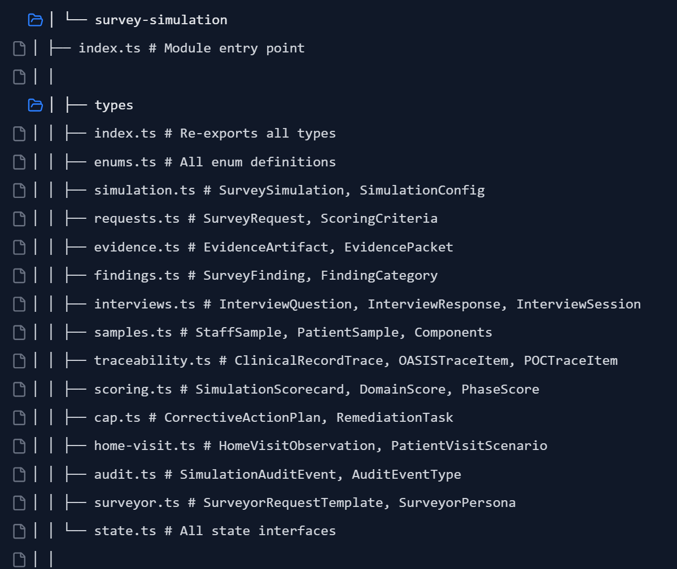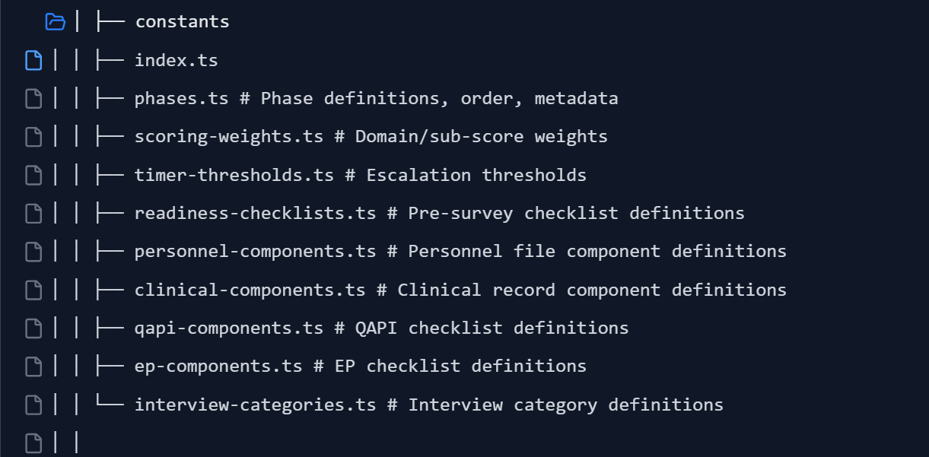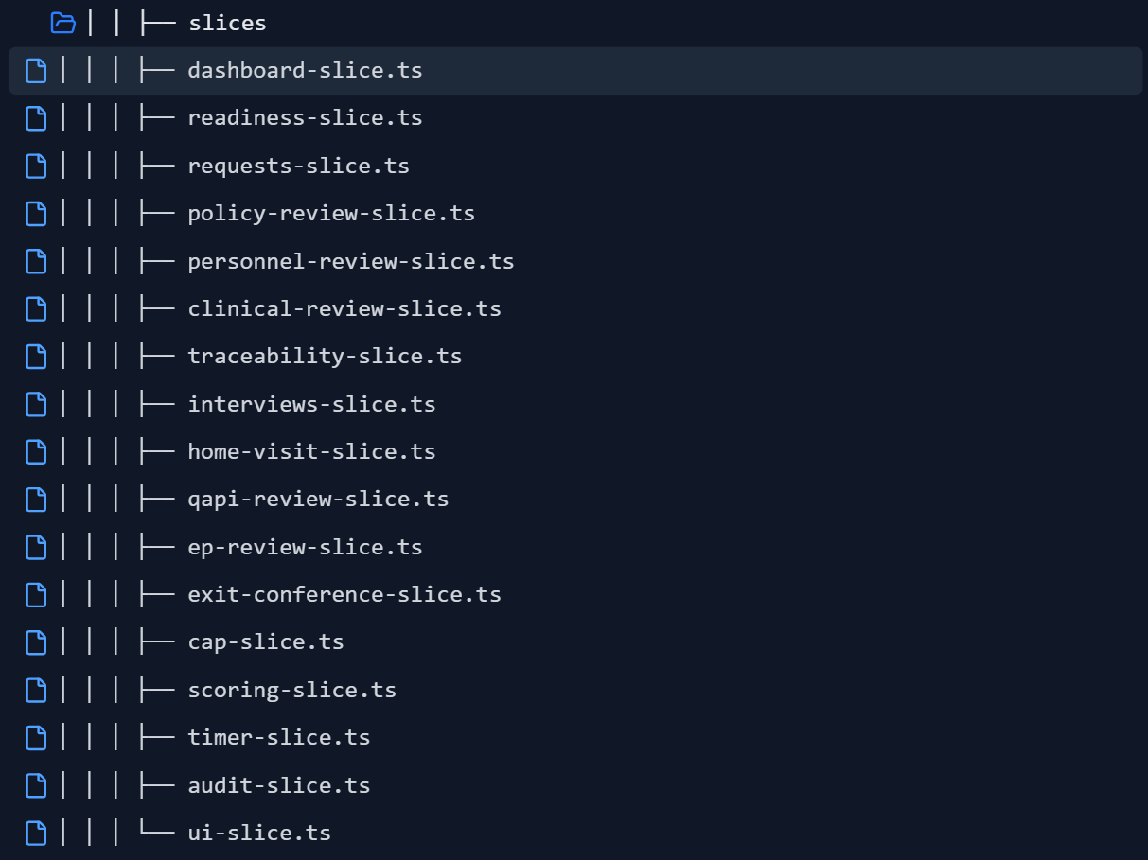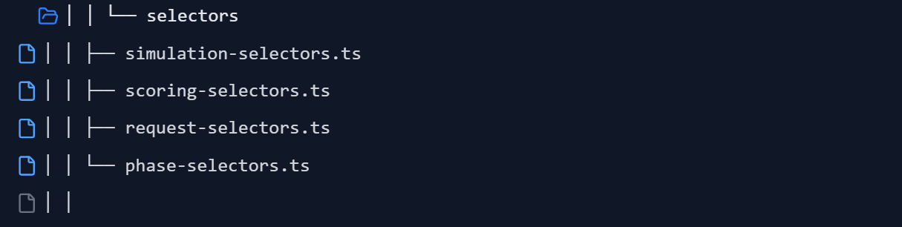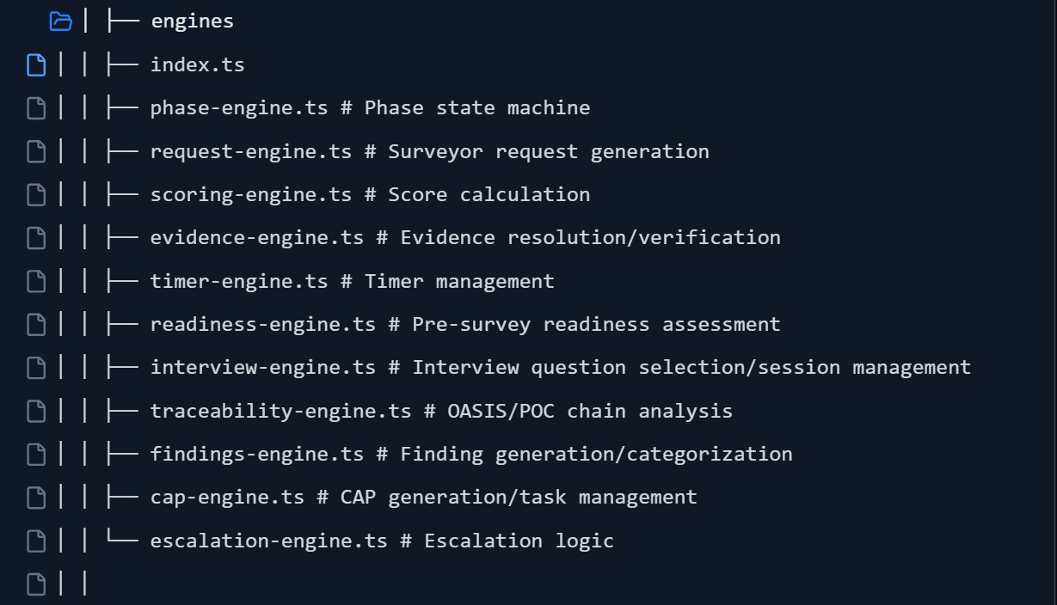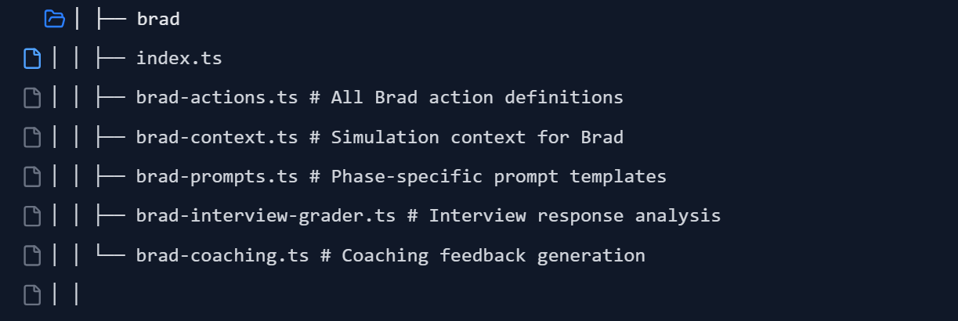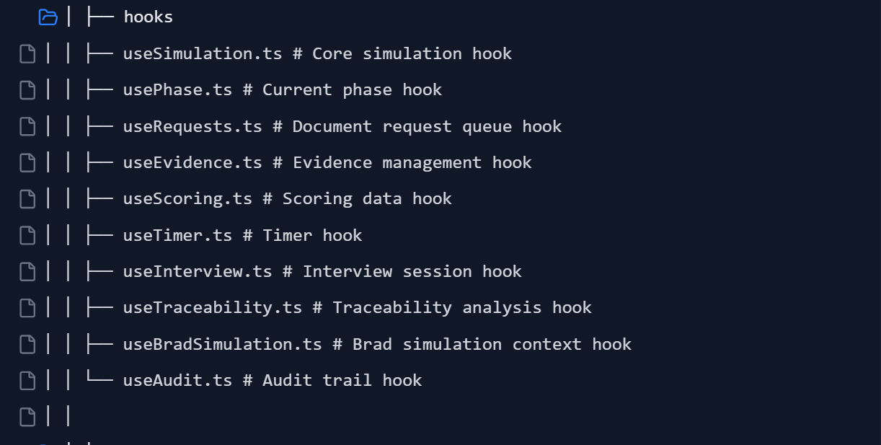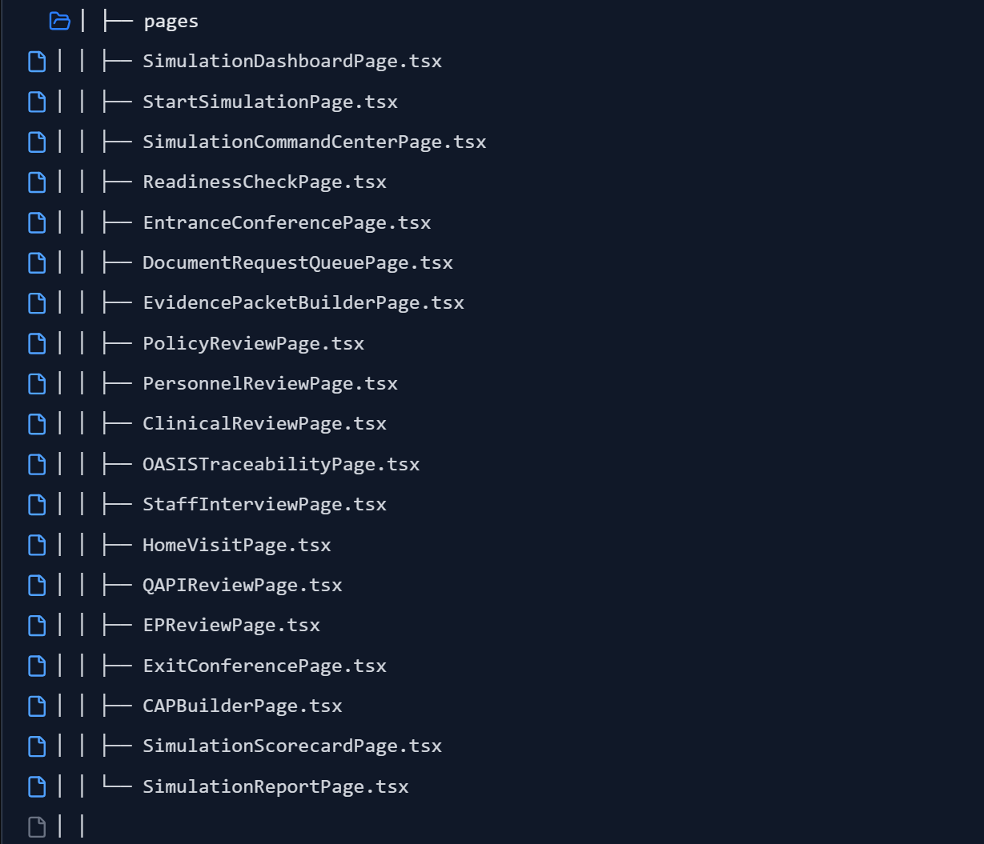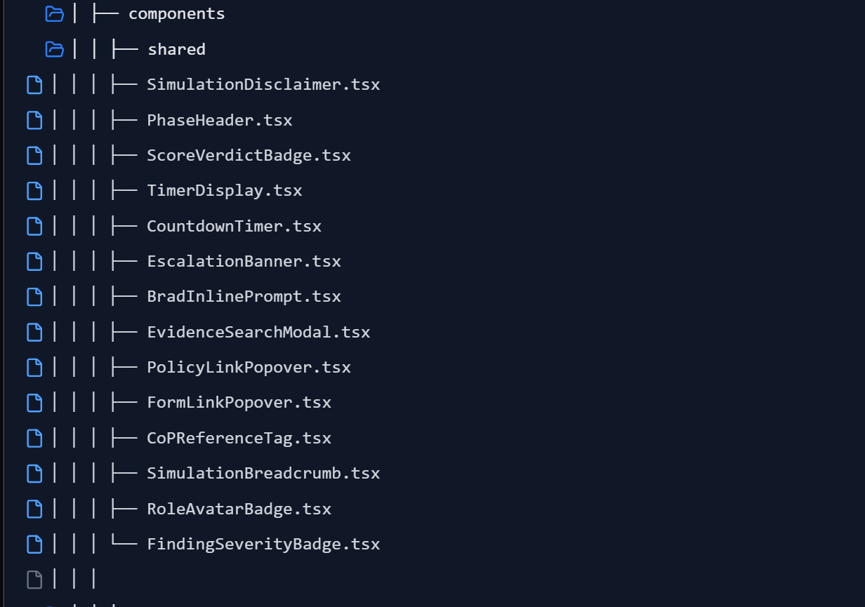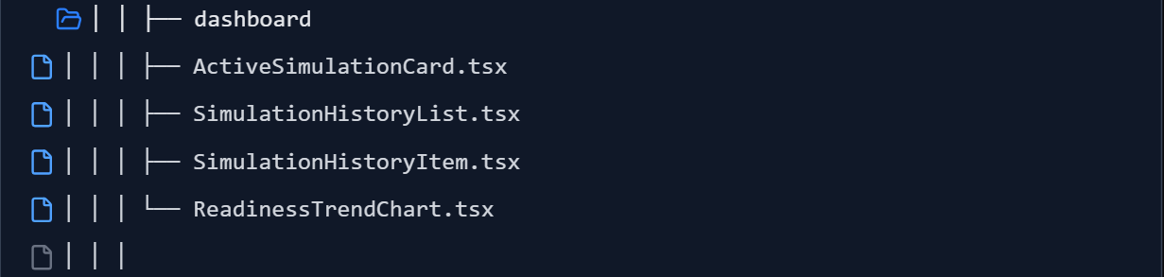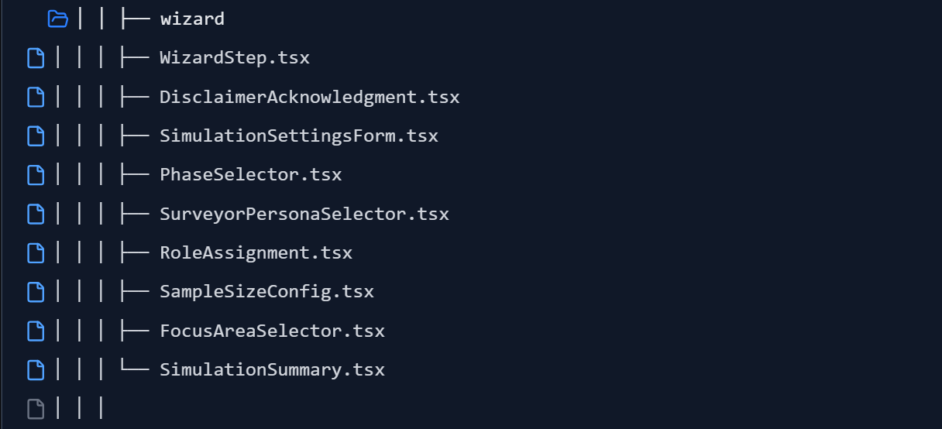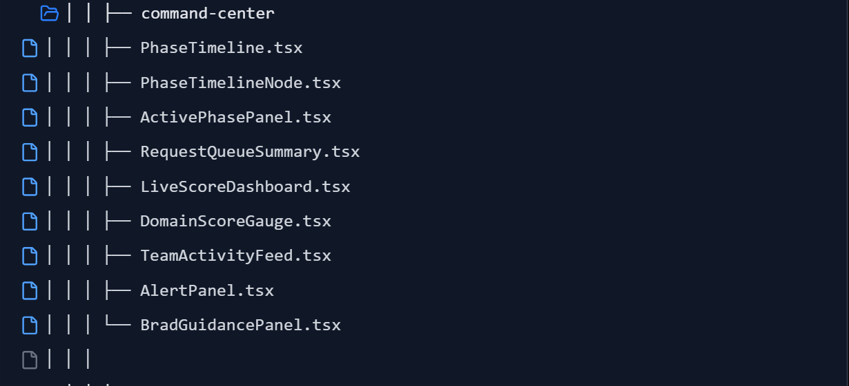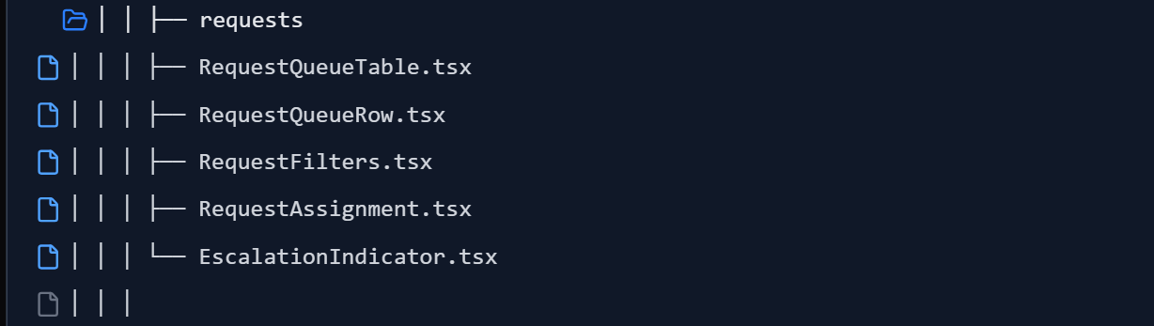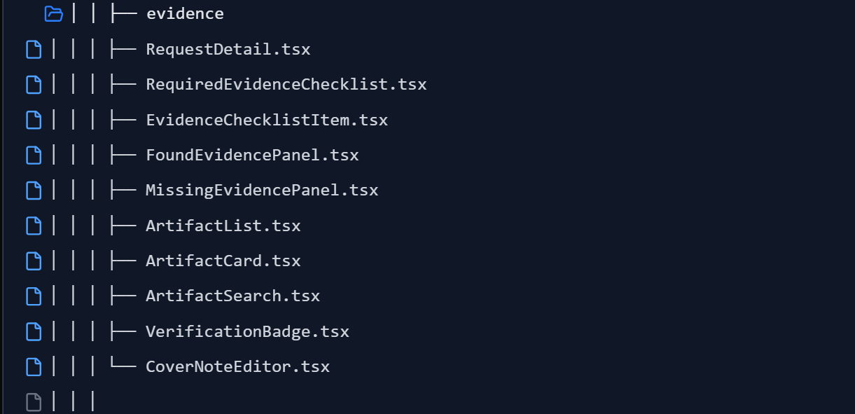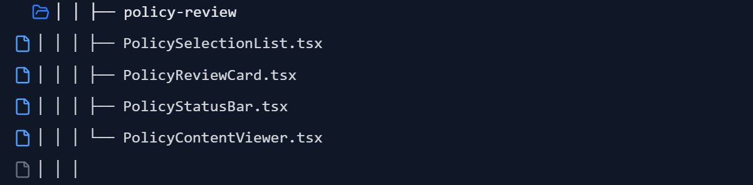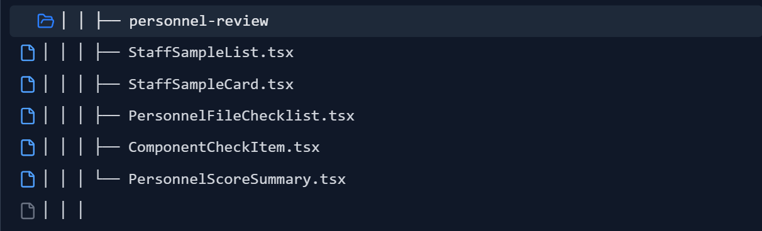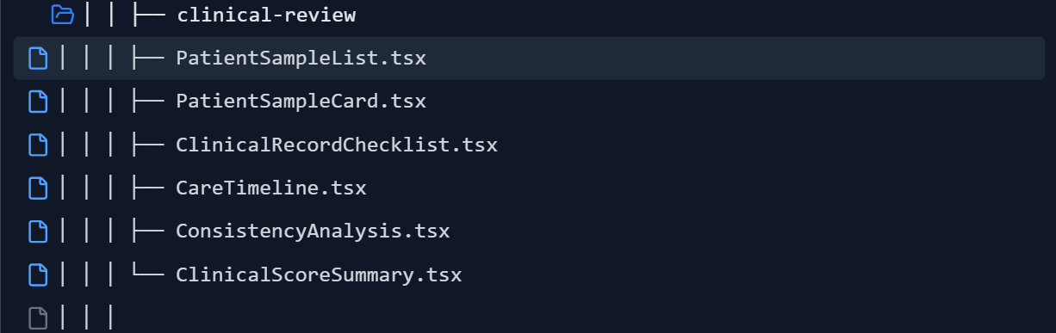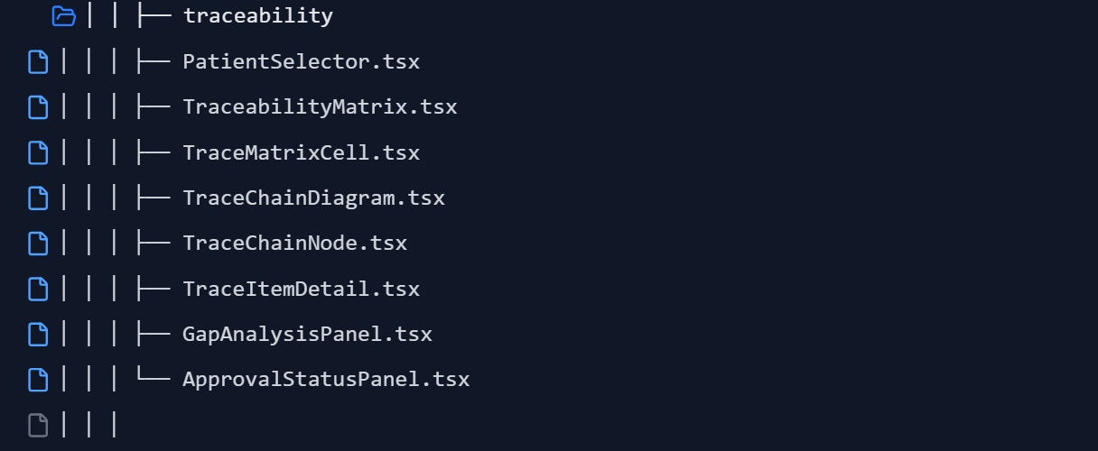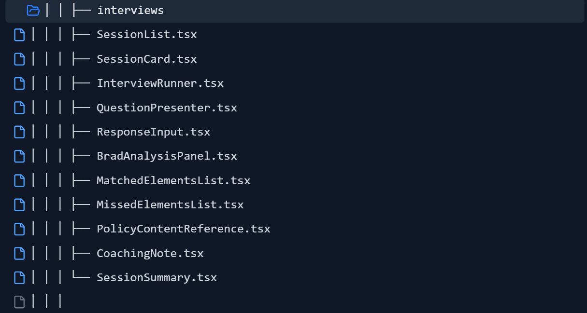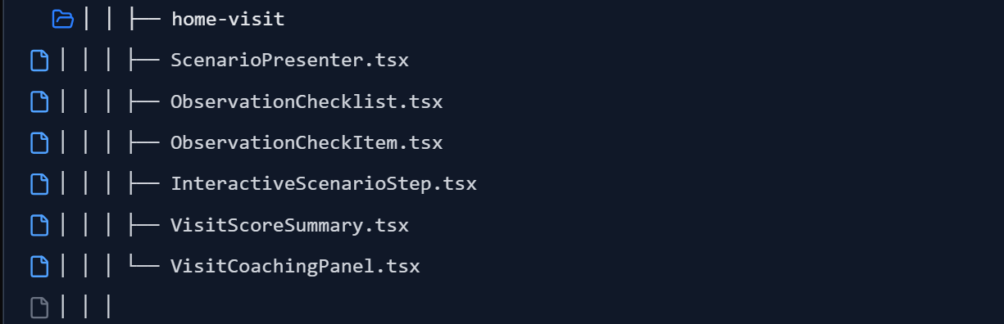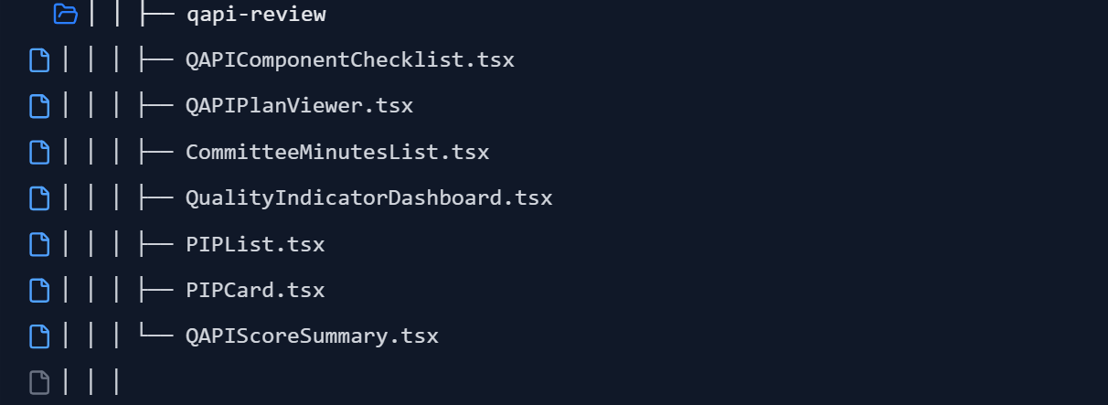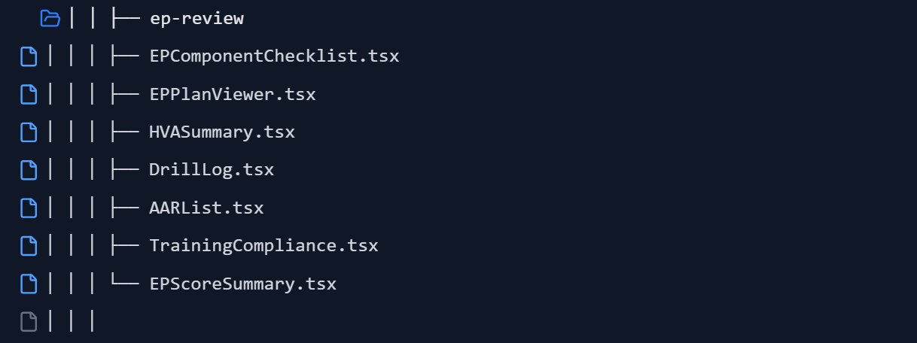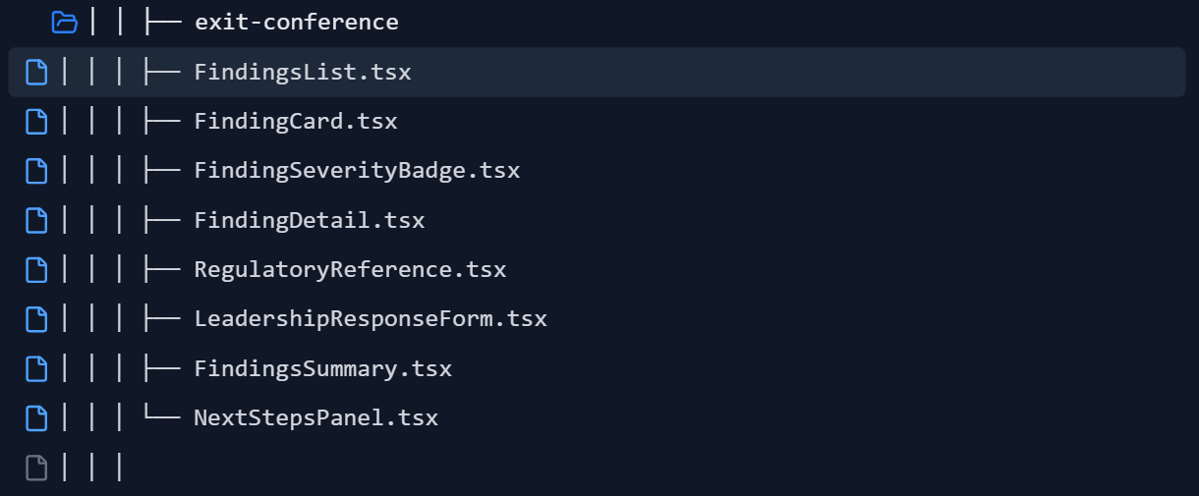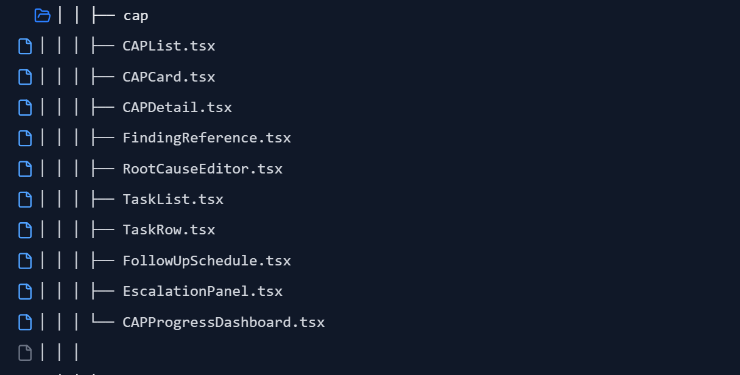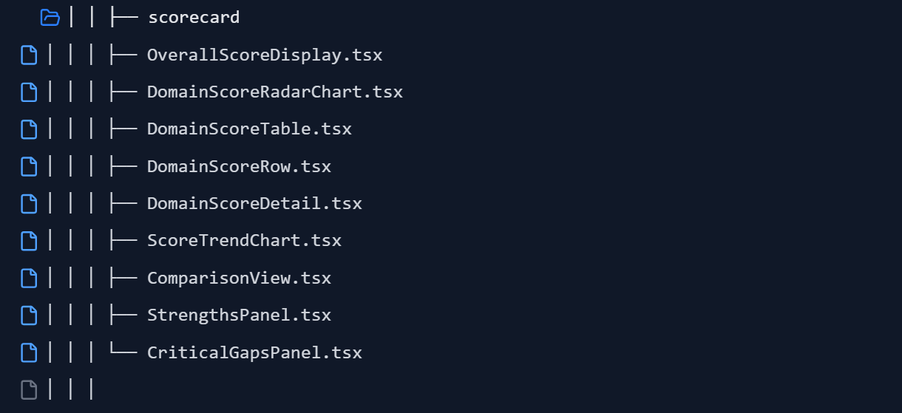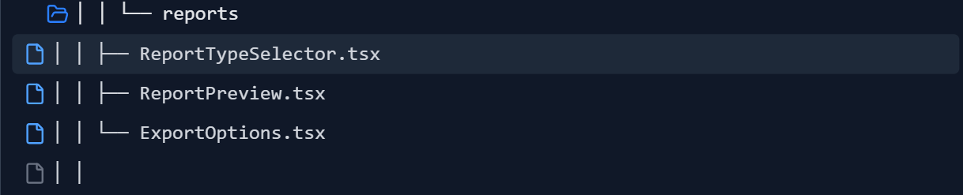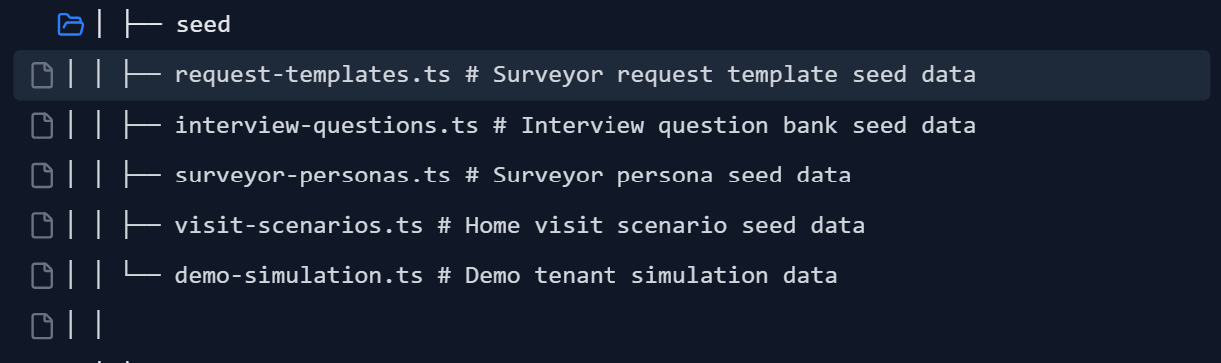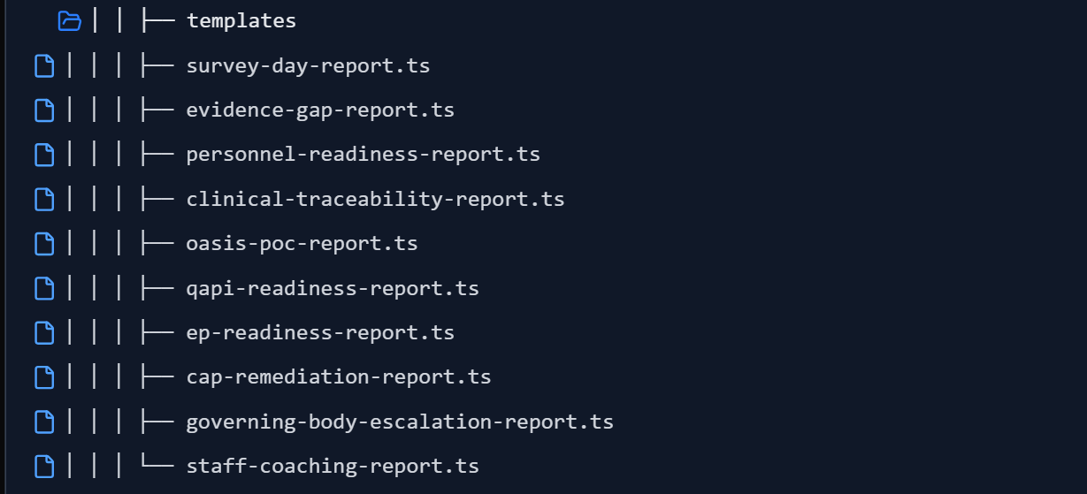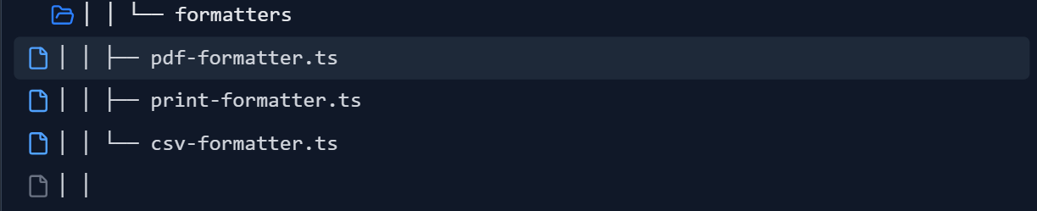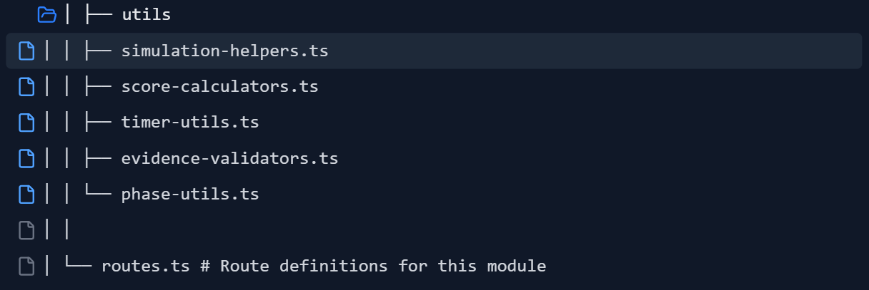

17.2 TypeScript Interfaces
Fully defined above in Section 5.1. Summary of all interfaces:
Interface | Count
Core enums | 16
Core simulation types | 7 (SurveySimulation, SimulationConfig, SimulationParticipant, PhaseRecord, etc.)
Request types | 3 (SurveyRequest, ScoringCriteria, SurveyorRequestTemplate)
Evidence types | 4 (EvidenceArtifact, EvidenceRequirement, EvidencePacket)
Finding types | 1 (SurveyFinding)
Interview types | 4 (InterviewQuestion, InterviewResponse, InterviewSession, InterviewScoringRubric)
Sample types | 4 (StaffSample, PatientSample, PersonnelFileComponent, ClinicalRecordComponent)
Traceability types | 4 (ClinicalRecordTrace, OASISTraceItem, POCTraceItem, TraceGap)
Scoring types | 4 (SimulationScorecard, DomainScore, SubScore, PhaseScore)
CAP types | 3 (CorrectiveActionPlan, RemediationTask, FollowUpCheck)
Home visit types | 3 (HomeVisitObservation, PatientVisitScenario, VisitObservationItem)
Audit types | 2 (SimulationAuditEvent, AuditEventType enum)
Surveyor types | 1 (SurveyorPersona)
State types | 20+ (all store state interfaces)
Total | ~70+ interfaces/types

17.3 State/Store Design
Fully defined above in Section 12. Architecture summary:
- State management: Zustand (or similar) with sliced architecture
- 20 state slices covering dashboard, all 13 phases, scoring, timers, audit, Brad context, and UI
- Actions: ~50+ action types covering the full simulation lifecycle
- Selectors: Derived state for computed scores, filtered queues, phase status
- Side effects: CMS API persistence, Brad API calls, timer intervals, audit logging, notifications

17.4 Route Map
Fully defined above in Section 10.1. 19 routes total:
/survey-simulation → Dashboard
/survey-simulation/new → Start Wizard
/survey-simulation/:simId → Command Center
/survey-simulation/:simId/readiness → Readiness Check
/survey-simulation/:simId/entrance-conference
/survey-simulation/:simId/document-requests
/survey-simulation/:simId/document-requests/:requestId
/survey-simulation/:simId/policy-review
/survey-simulation/:simId/policy-review/:policyId
/survey-simulation/:simId/personnel-review
/survey-simulation/:simId/personnel-review/:sampleId
/survey-simulation/:simId/clinical-review
/survey-simulation/:simId/clinical-review/:sampleId
/survey-simulation/:simId/oasis-traceability
/survey-simulation/:simId/oasis-traceability/:traceId
/survey-simulation/:simId/staff-interviews
/survey-simulation/:simId/staff-interviews/:sessionId
/survey-simulation/:simId/home-visit
/survey-simulation/:simId/home-visit/:observationId
/survey-simulation/:simId/qapi-review
/survey-simulation/:simId/ep-review
/survey-simulation/:simId/exit-conference
/survey-simulation/:simId/cap
/survey-simulation/:simId/cap/:capId
/survey-simulation/:simId/scores
/survey-simulation/:simId/report
/survey-simulation/templates → Admin: Request Templates

17.5 Component Map
Fully defined above in Section 11.1. Summary:
Component Category | Count
Shared components | 13
Dashboard components | 4
Wizard components | 9
Command center components | 9
Request queue components | 5
Evidence builder components | 10
Policy review components | 5
Personnel review components | 5
Clinical review components | 6
Traceability components | 8
Interview components | 11
Home visit components | 6
QAPI review components | 7
EP review components | 7
Exit conference components | 8
CAP builder components | 11
Scorecard components | 10
Report components | 3
Total | ~137 components

17.6 Integration Map
Fully defined above in Section 15. 10 integration targets:
- Policy Library — read policies, check status, display content
- Forms Library — resolve forms, verify availability
- Appendix System — resolve appendix references
- Workflow Engine — check workflow status, trigger remediation workflows
- Regulatory Events Calendar — schedule events, check recurring compliance
- Audit Mode — log audit events, audit evidence
- Onboarding/Competency Journey — verify orientation/training, route knowledge gaps
- Brad iAdministrator — 20+ Brad actions, phase briefings, coaching, grading
- Print/Export System — all 10 report types in PDF/print/CSV
- Future Demo Tenant — seeded demo data, guided walkthrough

17.7 MVP Backlog
23 items (see Section 16.1). Estimated: 6-8 weeks.

17.8 Phase 2 Backlog
25 items (see Section 16.2). Estimated: 6-8 weeks.

17.9 Phase 3 Backlog
20 items (see Section 16.3). Estimated: 6-8 weeks.

17.10 Risks and Assumptions

Risks
# | Risk | Impact | Likelihood | Mitigation
R1 | Data model complexity — 70+ types may slow development | High | Medium | Implement incrementally by phase; use shared base types; validate with a prototype
R2 | Brad AI accuracy — Interview grading and coaching quality depends on AI capability | High | Medium | Design scoring rubrics with explicit element matching first; use AI as enhancement, not sole evaluator; allow human override
R3 | Integration depth — Simulation depends on rich data in policy library, personnel, clinical records | High | High | MVP must handle gracefully when source data is sparse; show what's missing as gaps rather than errors
R4 | Scope creep — 13 phases with deep functionality in each | High | High | Strict MVP scope enforcement; MVP focuses on breadth (all phases at basic level) before depth (detailed analysis in each)
R5 | Performance — Large simulations with many requests, artifacts, audit events | Medium | Medium | Paginate audit events; lazy-load phase data; use server-side scoring for complex calculations
R6 | User overwhelm — Module is complex; users may not know where to start | Medium | High | Strong onboarding flow; Brad as guide; progressive disclosure; wizard-based start
R7 | Regulatory accuracy — CMS requirements change; simulation must stay current | High | Medium | Separate regulatory content (request templates, checklists) from code; make them data-driven and updateable
R8 | Timer system reliability — Compressed time modes and background timers may have edge cases | Medium | Medium | Thorough testing of timer edge cases; pause-safe timers; server-side timer validation
R9 | Multi-user synchronization — Phase 3 multi-user requires real-time state sync | Medium | Low (Phase 3) | Defer to Phase 3; evaluate WebSocket vs. polling; consider optimistic updates
R10 | Demo data realism — Demo must feel realistic to sell the product | Medium | Medium | Invest in high-quality seed data; have a clinical consultant review

Assumptions
# | Assumption | Validated? | Impact if Wrong
A1 | Policy library, forms library, and appendix system exist and have data | Partial | MVP cannot generate meaningful readiness scores without source data
A2 | CMS collections can store the data model without performance issues at scale | Unknown | May need to split large collections or use external storage
A3 | Brad can perform element-matching analysis on interview responses | Assumed | May need to simplify scoring to rule-based matching vs. AI analysis
A4 | Users have basic familiarity with Medicare survey process | Assumed | May need more educational content and guided flows
A5 | Single-user simulation is sufficient for MVP | Yes | Multi-user de

7. MVP Backlog
# | Task | Priority | Est.
1 | Create survey-simulations CMS collection | P0 | 2h
2 | Create survey-phases CMS collection | P0 | 1h
3 | Create survey-requests CMS collection | P0 | 2h
4 | Create survey-findings CMS collection | P0 | 1h
5 | Create survey-scores CMS collection | P0 | 1h
6 | Create survey-audit-events CMS collection | P0 | 1h
7 | Create interview-questions CMS collection (seed bank) | P0 | 2h
8 | Finalize TypeScript interfaces | P0 | 3h
9 | Build SurveyorRequestEngine.ts with 50 seed requests | P0 | 8h
10 | Build ScoringEngine.ts (4 MVP domains) | P0 | 6h
11 | Build EvidenceResolver.ts (search existing CMS) | P0 | 6h
12 | Build useSimulation hook (core state) | P0 | 4h
13 | Build usePhase hook (phase transitions) | P0 | 3h
14 | Build SimulationDashboard page | P0 | 6h
15 | Build StartSimulationWizard | P0 | 8h
16 | Build LiveCommandCenter | P0 | 10h
17 | Build EntranceConferencePage | P1 | 4h
18 | Build DocumentRequestQueue with timers | P0 | 8h
19 | Build EvidencePacketBuilder | P0 | 8h
20 | Build PolicyReviewStation | P1 | 6h
21 | Build ExitConferencePage | P0 | 6h
22 | Build FindingsGenerator | P0 | 4h
23 | Build CapBuilderPage (basic) | P1 | 4h
24 | Build SimulationReportPage | P0 | 8h
25 | Build PDF export for report | P1 | 4h
26 | Brad phase briefing hooks (13 phases) | P0 | 6h
27 | Brad locate_policy action | P0 | 2h
28 | Brad locate_form action | P0 | 2h
29 | Disclaimer component + display logic | P0 | 1h
30 | Audit trail logging | P1 | 3h
 | MVP Total |  | ~128h

8. Phase 2 Backlog
# | Task | Priority | Est.
31 | Build PersonnelFileReviewStation | P0 | 8h
32 | Build ClinicalRecordReviewStation | P0 | 8h
33 | Build OasisPocTraceStation with visual chain | P0 | 10h
34 | Build TraceabilityEngine.ts | P0 | 8h
35 | Build StaffInterviewSimulator | P0 | 10h
36 | Build InterviewEngine.ts | P0 | 6h
37 | Seed interview question bank (100+ questions) | P0 | 8h
38 | Brad grade_interview_response action | P0 | 4h
39 | Brad generate_interview_coaching action | P1 | 3h
40 | Complete ScoringEngine (all 10 domains) | P0 | 8h
41 | Build QapiReviewStation | P0 | 6h
42 | Build EmergencyPrepReviewStation | P0 | 6h
43 | Advanced CAP builder (verification workflow) | P1 | 6h
44 | Build all 10 report outputs | P1 | 12h
45 | CSV/JSON export for reports | P2 | 3h
46 | Personnel File Readiness Report | P1 | 3h
47 | Clinical Record Traceability Report | P1 | 3h
48 | OASIS/POC Consistency Report | P1 | 3h
49 | QAPI Readiness Report | P1 | 3h
50 | EP Readiness Report | P1 | 3h
51 | Staff Interview Coaching Report | P1 | 3h
52 | Governing Body Escalation Summary | P1 | 2h
53 | Brad generate_CAP action | P0 | 3h
54 | Brad escalate_finding action | P1 | 2h
 | Phase 2 Total |  | ~131h

9. Phase 3 Backlog
# | Task | Priority | Est.
55 | Build HomeVisitObservationSimulator | P0 | 10h
56 | Surveyor persona engine (4 types) | P1 | 8h
57 | Timed drill mode (sprint simulation) | P1 | 6h
58 | Multi-user role assignment (real users) | P0 | 10h
59 | Role-based views (restrict by role) | P0 | 8h
60 | Observer/trainer annotation mode | P1 | 6h
61 | Analytics dashboard (simulation history) | P1 | 10h
62 | Cross-simulation comparison | P2 | 6h
63 | Readiness trajectory trending | P2 | 4h
64 | Demo tenant: seed data generator | P0 | 8h
65 | Demo tenant: guided walkthrough mode | P1 | 6h
66 | Demo tenant: reset capability | P1 | 3h
67 | Accessibility audit and fixes | P0 | 4h
68 | Performance optimization | P1 | 4h
69 | Edge case handling and error states | P0 | 6h
70 | Integration testing with all CMS modules | P0 | 8h
 | Phase 3 Total |  | ~107h

10. Risks and Assumptions

Risks
Risk | Impact | Likelihood | Mitigation
CMS collections don't have enough seed data for realistic simulation | High | Medium | Create data seeder scripts; allow "mock data" mode for demo
Brad's interview grading may be inconsistent | Medium | Medium | Build structured rubrics; use policy text as ground truth; allow manual override
OASIS/POC traceability requires clinical data model not yet built | High | High | Design clinical record collections in Week 1; stub data for MVP
Timer-based UX may frustrate users in training mode | Medium | Low | Make timed mode optional; offer "practice mode" without timers
Report PDF generation complexity | Medium | Medium | Start with simple HTML-to-PDF; enhance in Phase 2
Multi-user real-time sync (Phase 3) adds complexity | High | Medium | Defer to Phase 3; use polling first, WebSockets later
Surveyor request engine needs domain expertise | Medium | High | Seed with 50 real-world-equivalent requests; allow admin to add custom requests

Assumptions
- hh-policies collection has 230+ policies that map to CoP domains — confirmed by schema inspection
- compliance-documents collection covers HIPAA, OSHA, EP, IC, Medicare — confirmed by category field
- Brad/iAdministrator can call records_search and files_search to locate evidence in real time
- Print/export system exists or can be built with standard HTML-to-PDF tooling
- Users will have been onboarded through the competency journey before running a simulation
- Clinical record data model does not yet exist and must be created
- Personnel file data model does not yet exist and must be created
- QAPI records data model does not yet exist and must be created
- Demo tenant will share the same schema but with isolated, resettable data

11. Open Questions
# | Question | Decision Needed By
1 | Should clinical records use a new CMS collection or integrate with an external EMR/EHR? | MVP Week 1
2 | Should personnel files be real staff data or fictional sample data for simulation? | MVP Week 1
3 | What is the minimum number of seed surveyor requests needed for MVP? (Proposed: 50) | MVP Week 1
4 | Should Brad grade interviews in real-time or batch after all answers submitted? | Phase 2
5 | Should the OASIS/POC trace use actual OASIS data or simulated OASIS records? | Phase 2
6 | Should multi-user mode use WebSockets or polling for real-time updates? | Phase 3
7 | Should demo tenant data be version-controlled in the repo or seeded at runtime? | Phase 3
8 | What surveyor personas should we ship with? (Proposed: Standard, Detail-Oriented, Time-Pressured, Collaborative) | Phase 3
9 | Should the home visit observation simulator include video/VR capabilities in future? | Post-Phase 3
10 | Should simulation scores contribute to the onboarding/competency journey scoring? | Phase 2

Total Estimated Effort
Phase | Hours | Weeks (40h/wk)
MVP | ~128h | 3-4 weeks
Phase 2 | ~131h | 3-4 weeks
Phase 3 | ~107h | 2-3 weeks
Total | ~366h | 9-11 weeks

